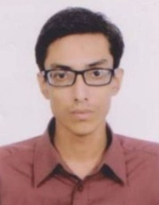
ORKO BARDHAN PROTIK
Rasos-3,East Mirabazar,Sylhet Main Post Office,Sylhet Sadar,Sylhet
Mobile: +8801742908028
Email: protik1516@gmail.com

Personal statement

A highly motivated and hardworking individual who has completed his H.S.C(Higher Secondary Certificate) and S.S.C(Secondary School Certificate) in 2012 and 2010 respectively with a point of 5.00 out of 5.00 and attended a university named "American international university of Bangladesh" and enrolled to B.Sc. in CSE.
I had completed IELTS with a band score of 6.

Key Skills

- Ability to take the initiative and work well under pressure.
- Accomplished communication skills, both written and verbal.
- Flexibility, whilst maintaining enthusiasm and commitment to each project
- Proficiency in all areas of Microsoft Office, including Access, Excel, Word and PowerPoint

Education

American International University of Bangladesh
(May 2013 – May 2018)

M.C College, Sylhet
(2010 - 2012)

Sylhet Govt. Pilot High School
(2002 - 2010)

References

1.Subrata Kumar Bardhan 2.Shasank Shekhar Paul
Assistant Professor & Head of the Department Advocate
Department of philosophy Judge Court, Sylhet
Kanaighat Govt. College, Kanaighat Sylhet Mobile: +8801779006631
Mobile: +8801712652671

