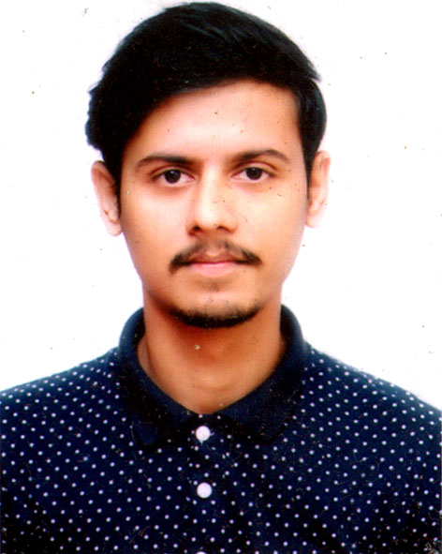 | PRANTO GHOSH  Chamelibag 2 no road, Majortila  Sylhet 3100.  Mobile: 01744-504339  E-mail: prantoghosh8@gmail.com

Career Objective:
To develop a career in a professional and challenging environment that ensures me the best use of my knowledge, skills, efficiency and creativity and where there is an opportunity of self-assessment and improvement through gathering & sharing knowledge.

Academic Standings:

Exam | Year | Institution |  | Concentration |  | Status
M.B.A  B.B.A | 2022  2019 | National University  National University | Management  Management |  |  | 3.09 (out of 4)  3.03 (out of 4)
H.S.C | 2014 | Scholarshome, Sylhet |  |  | Business Studies | 4.90 (out of 5)
S.S.C | 2012 | Razar Bazar Govt. high school |  |  | Science | 4.50 (out of 5)

Relevant Skills:

Language Skills  Interpersonal skills  Computer skills | Conversant in English and Bengal.  Comfortable in communicating with people of every level, motivation and leadership skills.  Excellent in data searching and analysis using MS Excel.  Excellent in report presentation using MS Power Point.  Excellent in report writing using MS Word.  Excellent in Web browsing & social networking.  Excellent in HTML

Personal Details:
Father’s Name : Rana Prasad Ghosh
Mother’s Name : Annapurna Ghosh
Date of Birth : 02-09-1996
Blood Group : A+
Nationality : Bangladeshi
National ID No : 19963612613000135
Marital Status : Unmarried
Religion : Hindu
Permanent Address : Amo T.E , Chunarughat,Habiganj.
Present address : House 31/2, Chamelibag 2 no road, Majortila, Sylhet

Interest:

- Interest in sports, music, travelling and tourism.
- Interest in doing voluntary jobs for the underprivileged children.
- Interest in arranging different kind of cultural events.

Involvement:

- Worked as a Traine in E-SHOP of ICT DIVISION for 2 month.
- Worked as a Professsional Freelancer in TMSS. For 3 month.
- Worked in a team Environment.
- Practice occupational health and safety.
- Demonstrate work value.
- Perform search engine optimization techniques

Personal Attributes:

- Ability to easily assimilate new ideas, concepts, methods and technologies and adaptability in every changing environment.
- Believe me as a enthusiastic learner and have the utmost curiosity to confront challenges & learn from them with temptation.
- Can lead and work in a team with absolute Pro-activeness.

Reference:

Tarapada Saha  Senior Officer  Pubali bank Limited  Mirpur, Dhaka  Cell: +8801712-281816 | Professor Joyonto Das  Head of Management department  Madan Mohan College  Tarapur Campus, Sylhet  Cell: +88 01713-388657
Declaration:
I am certifying that this resume correctly describes my biography, education and all other information.

