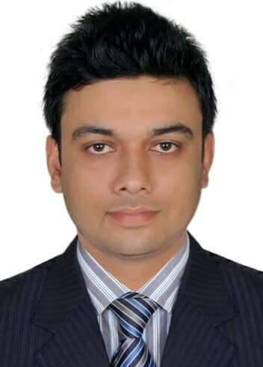
Gypsum fozila tower
1829 /A. 5th floor falt # B2 East
Muhori para,North Agrabad ,
Chittagong 4224.
+8801912090318
mesba01912@gmail.com

MD.MESBAH UDDIN BHUIYAN
Career Objective:
To work in the capital market of depend private Bank or Public of Bangladesh. in its portfolio management Department and grow rapidly with increasing responsibilities.

Academic Qualification: Employment Experience:
Masters Total Year of Experience : 2.5 Years
2016
Major- Economics, Executive Trade ( June 10, 2017 – TO PRESENT)
Grade- Second Class Island securities ltd.
National University. Job Location : Agrabad Branch, Chittagong.
Department: Trade
B.S.S Duties/Responsibilities:
2015
Major- Economics,
Grade- Second Class Execute clients order through CSE gotext & DSE Flex-TP
National University. terminal by following all trading rules Communicate with
the clients and inform day-to- day market updater scenario
Prepare weekly business progress report and submit to Line
2008
H.S.C Manager Review client position on regularly Monitoring
Group- COMMERCE margin client`s exposure and make necessary
GPA- 2.50 out of 5 communication to clients.
Feni Public College.
2006
S.S.C Generating and achieving brokerage targets. Procure new
Group- COMMERCE businesses and achieve yearly business target Provide all
GPA- 3.44 out of 5 sorts of statements as per client requirements Analyze
Bhore Bazar Advocate Belayet Hossain Analyze market trend and company financial statements
High School to extend better service to the clients File and report all
relevant news to the respective authorities Complying
with all rules, regulations of BSEC, DSE & CDBL. Any
other responsibilities assigned by the Management.

Training Summary:
Training title: Day-long Training Program on Investment in Capital Market
Topic: Financial Analysis.Trading types of buy /sell. margin trading
and corporate actions.insidertrading and market manipulation.
Jointly organisedby BICM and CSE, Chittagong, Bangladesh. (2018)

Training title: Training on financial of protfolio Analysis.
Topic: Portfolio Analysis
Jointly organisedby BICM and CSE, Chittagong, Bangladesh..(2018)

Extra Curriuculum:

Travelling, Gardening , Playing Cricket, Reading newspapaer.

Personal Details : Reference (s):

Father's Name | : | KAMAL UDANDIN BHUIYAN Md. Delwar Hossain
Father's Occupation | : | Retried Secretary (Rtd)
Mother's Name | : | MONOARA BEGUM Bangladesh Fisheries Development Corporatoin
Mother’s Occupaton | : | Housewife Flat# C-2 & D-2, Bulbul Nikbeton
Date of Birth | : | August 12, 1990 Plot# D-31, Road# 5/1,
Gender | : | Male South Banasree, Dhaka-1219
Marital Status | : | Single 01716-470827
Nationality | : | Bangladeshi
National Id No. | : | 19903019476000048 Md.Fazlul karim
Religion | : | Islam Assistant General Manager
Permanent Address | : | Vill: Mohodia, Bhore bazar, Basic Bank Limited
Sonagazi, Feni 3932 14.Dilkusha C/A Dhaka -1000.Bangladesh
01552314855 karimf@basikbanklimited.com

Declaration


I certify that all of the information contained in my CV is factually correct and honestly presented. I understand that, my acceptance may be revoked at any time if the relevant information found to have been falsified or withheld.

Signature

