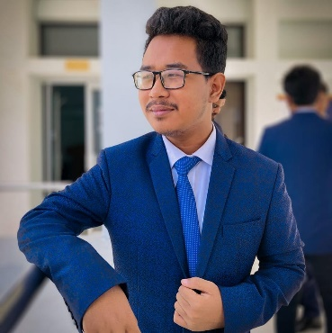 | Patrik Abri  - Dio  Business Student
CONTACT  Rohena Cottage, Pirer Bazar  Khadimpara,Sylhet  01829755473  Patrikabridio.aiba@gmail.com  Communication  Successfully managed client relationships, addressing concerns and providing timely updates.  Leadership  Facilitated effective communication within cross-functional teams, fostering collaboration and teamwork. | Education  Notre Dame Collage Mymensingh  - Army Institute Of Business Administration, Sylhet  - Relevant In Faculty Of Business.  Experience  - Formerly used to work in Upazila Computer Tranning Center in Haluaght.  - Highly experienced PPT editor.  - Managed a record label from 2018 to 2024.  - Formerly music producer at Voice Of 04.  References  Spotify Artist Profile:  https://open.spotify.com/artist/4810P7ASR0PWvu4hy7CO3X?si=Uq6-TCA7Qbu9anY1DRzjAQ

