Curriculum Vitae 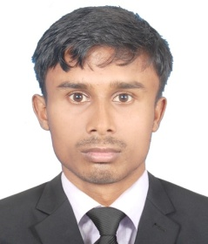
Name : Rubel Roy
Address : Prottsha 282,Kanishail, Sylhet
Email : rubelroy50@gmail.com
Contact : 01716-098278
01742787865

Career Objective:
To work in an environment where there is an opportunity of self assessment and self improvement in both individual and group based work that will ultimately lead to the further development of the professional level.
Principle
“Honesty, Hardworking and Responsibility Success is the motto of my life.
Educational Qualification:
H.S.C: Higher Secondary Certificate
Year : 2014
Result : GPA 2.96
Group : Humanities
Institute : Chatalpar Degree College
Board : Comilla

S.S.C : Secondary School Certificate
Year : 2012
Result : GPA 3.00
Group : Business Studies
Institute :Bangalpara High School.
Board :Dhaka.

Computer Literacy:
*Application Packages :MS Word, MS Excel, MS Power Point
*Internetwork: Using Internet browsing, E-Mailing & Other Communication.
Personal Skill:
Key Skill:
*Able to work with multicultural people.
*Ability to work under stress and strict deadlines.
*Both proactive and self-starter.
*Positive mental attitude
*Leadership qualities
Language Proficiency:
Bengali : Maternal Language
English : Good in speaking and writing
Personal Information:
Name : Rubel Roy
Father’s Name : Rabindra Roy
Mother’s Name : Anita Roy
Religion : Hindu
Permanent Address : Vill :Bangalpara P.O:Ashtogram,
P.S: Ashtogram, Dist: Kishoreganj.
Date of Birth : 14/06/1996
Place of Birth : Kishoreganj
Nationality : Bangladeshi by Birth.

Signature & date

