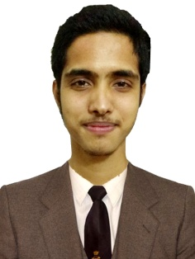
Curriculum Vitae

RAIHAN-UL ISLAM DIPU
Address: Shurovi 60, Rajpara, Tilagore, Sylhet
Mobile : 01926323545
E-mail : rayhandipu6@gmail.com

CAREER OBJECTIVE

To take up a challenging career and grows with honesty, loyalty, good relationship and best performance and translate my experience , knowledge, skills and abilities into value for a organization.

ACADEMIC QUALIFICATION

Name of Exam | Subject | Passing Year | GPA | Board
SSC | Business Studies | 2016 | 4.22 | Sylhet
Diploma in Engineering | Civil Technology | On Going (Final Year) | 3.36 (Last semester) | Sylhet

COMPUTER SKILLS
MS Word, Excel, Power Point, Adobe Photoshop, Adobe Illustrator(Photo Editing & Design, Logo Making & Design, Banner Design),Adobe Premier Pro, Internet etc.

STRENGTH FACTOR
Good strength of working with team. Strong ability to work creative & determination.

PERSONAL PROFILE
Father Name : Late. Shafiqul Islam
Mother name : Late. Shaheda Islam
Date Of Birth : 04/01/2000
Gender : Male
Religion : Islam
Nationality : Bangladeshi

DECLLARATION

I do hereby declare that the statements made in this document are true to the best of my knowledge and belief.

