RESUME OF
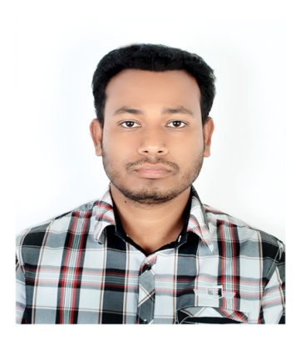

Nazmus Sakib

Contact Address : Vill: Chhatak Cement Factory,P.O: Chhatak Cement Factory-3081

P.S: Chhatak, Dist: Sunamgonj. Bangladesh

Contact Number : +8801868812703
E-mail ID : nazsakib111@gmail.com

OBJECTIVE

To work in a challenging and competitive environment where a strong sense of responsibility and commitment is required; where dignity of work provides job satisfaction, and work environment provides potential avenues for learning, growing, and reaching the highest level in the organization.

ACADEMIC QUALIFICATIONS
Name of the Degree | Subject | Institutions | Year | GPA | Board / University
S. S. C. | Business Study | Chhatak Cement Factory High School | 2010 | 3.81 | Sylhet
H. S. C. | Business Study | Chhatak Degree College and University | 2012 | 3.80 | Sylhet
Degree(Pass) | Becholor of Business  Studies | Chhatak Degree College and University | 2015 | 2nd Class | National University Gazipur

COMPUTER LITERACY

Operating System: Microsoft Windows XP, Microsoft Windows 7, Microsoft Windows 8, Microsoft Windows 10 and Linux.
Software: Adobe Photoshop, Ms Office,Excell.

Job INTARNY literacy

Company Title | Job Title | Institute | Duration
Ya Nabee Shamal  Modern Tarde LLC  Sultante Of Oman | Office Manager | Yanabee Shamal  Modern Trade LLC | 2 Years

 | PERSONAL INFORMATION
Father’s Name |  | : | Md. Askhar Ali
Mother’s Name |  | : | Dilara Begum
Present Address |  | : | Chhatak Cement Factory
Permanent Address |  | : | Vill: Kalaruka | P.O: Kalaruka
 |  |  | P.S: Chhatak | Dist.: Sumangonj
Date of Birth |  | : | March 09,1993
Religion |  | : | Islam
Nationality |  | : | Bangladeshi
Place of birth |  | : | Chhatak Cement Factory
Weight |  | : | 65 kg
Height |  | : | 5 feet 6 inch
Blood Group |  | : | B+
National ID No |  | : | 19939022302000021
Gender |  | : | Male
Marital Status |  | : | Unmarried

DECLARATION

I, the undersigned declare that the information specified in this Resume is true to the best of my belief and knowledge and correctly describes my experience and myself.

__________________________

(Nazmus Sakib)

