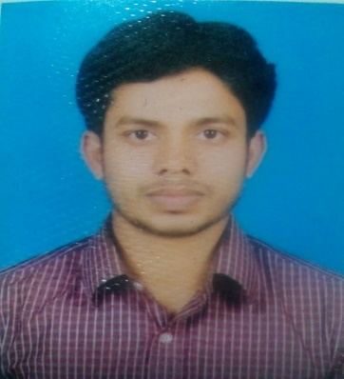
RESUME OF

MD NURUZZAMAN
Call no. +8801779239844
+8801869903322
E-maill: mdzaman.bd.bangla@gmail.com

CAREER OBJECTIVE

Looking for hard and challenging job in organization that –
- I would like to utilize my potentiality & skills to do something innovative &from where I will able to enhance my knowledge
I would like to develop my professional managerial administrative skill & knowledge through participation in the development activities & by using modern scientific techniques .

EDUCATIONAL QUALIFICATIONS

Post Gradute
Subject : Masters In Bangla
Result : 3.03 (Out of 4.00 )
Year of Examination : 2019
Institute : Rajshahi College, Rajshahi

Bachelor of Arts
Subject : BA(Hons) In Bangla
Result : 2.98 (Out of 4.00 )
Year of Examination : 2016
Institute : Tongi Govt. College Gazipur , Dhaka

Higher Secondary Certificate
Year of Examination : 2012
Group : Science
Result : 4.20 (Out of 5.00 )
Institute : Jahangirpur Govt. College, Mohadebpur .
Board : Rajshahi

Secondary School Certificate
Year of Examination : 2010
Group : Science
Result : 5.00 (Out of 5.00 )
Institute : Bagdob High School
Board : Rajshahi

COMPUTER PROFICIENCY

Operating System : Windows XP , Windows 7 , Windows 10 .
- Application Program
(1). MS Office – ( Ms Word, Excel, PowerPoint, MS Access )
(2). Internet Browsing & Communication.
- Printing.
Typing Spreed are very fast both Bangla and English

PERSONAL DETAILES

- Name : Md Nuruzzaman
- Father’s Name : Md. Soleman Ali
- Mother’s Name : Nurunnahar Begum
- Date of birth : 15 July, 1994
- Present address : Vill. : Chalk kondurppur , Post : Chandash, Thana : Mohadebpur,
District : Noagoan .
- Permanent : : Vill. : Chalk kondurppur , Post : Chandash, Thana : Mohadebpur,
District : Noagoan .
- Current Location : Noagoan
- Place of birth : Noagoan
- Nationality : Bangladeshi
- Religion : Islam
- Blood Group : O(+) ev
- Marital status : Unmarried
LANGUAGE PROFICIENCY

Bengali : Mother Tongue
Engliush : Good both in Reading, Writimg &Speaking

ADAPTATION OF COMMUNICATION SKILL

- Strong desires for leading an honest life with dignity
- Abillity to work hard & well set-up in project
- Abillity to express ideas and concepts clearly and concisely in written and oral form
- Abillity to work in a multicultural environment and to work under pressure with groups
- Self-movitated and committed to outstanding achievements
- Strong Communicition and interpersonal skills

DECLARTION
Ihereby declare that all the above statem,ents are correct and complete to tha best of my knowledge.

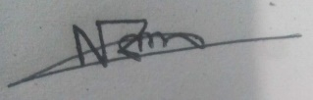

(Md Nuruzzaman )

