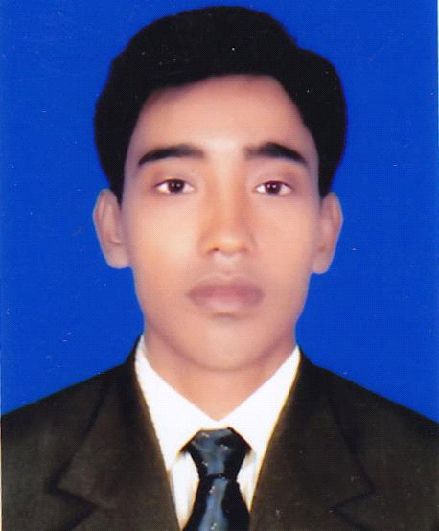

RESUME OF RIPON MIA

Present Address: Jamgora, Ashulia,Savar, Dhaka.
Mobile:01727550638,
E-mail:ripondewan@yahoo.com, fahadsworld@yahoo.com

Career Objective:
I have the desire to serve as a dynamic and generous management team member in a multinational organization, which offers progressive career growth through perfect teamwork. I am best fit with an organization that offers challenging career for further development of employee skills.

Career Summary:
To develop my career in an esteem organization to achieve the zenith of success which I deserve.
Special Qualification:
Human resource and Compliance
Employment History:
Total years of Experience: 6 (years).
Audit Knowledge
Have through root experiences to Carry over and face audit for WRAP, BSCI, SEDEX, BETTER WORK, GMP,FCCA, C-T PAT ,ACCORD,ALLIANCE also faced audits for different buyers.

01. Executive Admin & Compliance (01 March 2017–Continuing)

Safaa Sewing Ltd.
Palmal Group

Company Location : Jamgora, Ashulia, Savar, Dhaka
Department : Admin HR & Compliance
Major Job Responsibility
Admin & HR Related Job
- Supervise and guide the HR Team consisting of KPI & Performance Management, Recruitment & Selection, Compensation and Benefits, Training and Development, Employee Relations etc.
- To understand the business plan and prepare organogram , job description/ Roles and Responsibilities.
- To take initiatives to maintain a disciplined environment in factory premise.
- Monitor and administer salary and benefits structure of the factory in accordance with the employment market conditions.
- Responsible for handling employee grievances.
- Handling the accidents and such cases, manage, coordination with Admin team for any kind of assistance.
- Ensure proper guest handling process.
- Working closely with the all Departmental Heads to execute their resourcing needs by planning and forecasting needs throughout the year
- Assist for arrange the weekly/ monthly Coordination meeting.
- Any other responsibilities assigned by the management from time to time.
Compliance Related Job
- Coordinate Buyer /Agent/ Third party audit program.
- Prepare corrective action (CAP) after completing of compliance audit and keeping all relevant documents separately.
- Prepare monthly compliance report related to regular compliance activities
- Managing & Monitoring environment health and safety issues in the factory.
- Prepare factory for facing different audit such as Social/Ethical/ Environment /Technical with coordination of production team.
- Determine and seek individual training requirement through need.
- Make annual & monthly training & events schedule.
- Conduct awareness program for workers in the factory regular basis.
- Follow up renewal of all licenses.
- Handling all types of social /Environment / FCCA (Technical) /Fire & Safety/Chemical safety/Accord/ BSCI/WRAP/C-TPAT/BWB and others certifications.
- Ensure the buyer COC, Factory Enlistment & Evaluation.

02. Officer HR & Compliance (01 December 2015–February-2017)

Zas Apparels (pvt).Lt.d

Company Location : Fatullah Narayangonj-1400
Department : Admin HR & Compliance
On Job Achievement- Promoted as Sr. Officer – HR & Compliance
Workers Recruitment /Counseling/training /workshop/Seminars // Leave Management / Personal Filing /Disciplinary Action /Performance Evolution and Human Capital Development work .Attendance Report ,Leave Register Monitoring etc ,All Tainting program maintain,
All HR & Compliance Related activates .

03. Personal Officer (01 February 2013 to 31 November 2015).
Dekko Ready wears Limited
Company Location: Mirpur: 7. Dhaka1216.
Department: H.R, Admin & compliance

Duties & responsibilities:

- Taking care of personal file, Workers recruitment, Attendance Report, overtime Follow-up, leave register Follow-up, Salary sheet making & payment, Ensure all the papers are up to date.

- Academic Qualification:

Exam Title | Concentration/Major | Institute | Result | Year
Master of Arts | Islamic Studies | National university | Second Class | 2010
Bachelor | Arts | National university | Second Class | 2008
Higher secondary Certificate | Humanities | Matlab Degree collage | CGPA :2.40 out of 5 | 2004
Secondary School certificate | Science | Indoria high School | CGPA:2.63 Out of 5 | 2001

- Professional Qualification:

Certification | Institute | Location | From | To
Basic Computer | SS Computer | Pallabi, Mirpur, Dhaka | 01 January, 2010 | 31 May, 2010
PGD-HRM | BIHRM | 15, Indira Road, Farmgate, Dhaka | 01 January, 2017 | Septenber-2017

- Specialization:

Fields of Specialization : | Description
- Compliance Officer  - Merchandising | I Have good knowledge about HR & Compliance
[[[

- Language Proficiency:

Language | Reading | Writing | Speaking
English | High | High | Medium
Bangla | High | High | High

Personal Details:
Father’s Name : Late Abdur Rahman Dewan
Mother Name : Amena Begum
Date of birth : 01 March 1986
Gender : Male
Marital : Unmarried
Nationality : Bangladeshi By Birth
National ID No : 1317990348246
Religion : Islam
Blood Group : O+ve
Permanent Address : Vill # Noyakandi, P.O.# Induria, P.S # Matlab Uttar, District # Chandpur

Reference:

Name : G.M. Fahad Ibne Huda Name : Shakhawat Hossain Sumon
Organization : Palmal Group Organization : Raj Washing Plant Ltd
Designation : Manager (HR & Compliance) Designation : Manager ( HR.Admin & Compliance)
Address :Jamgora, Ashulia, Dhaka Address : Tongi Gazipur
E-Mail : Compliance.safaa@palmalgarments.com E-Mail : Shakhwat @Yahoo.com
Mobile : 01720194040 Mobile :01674-964428
Relation : Professional Relation : Professional

