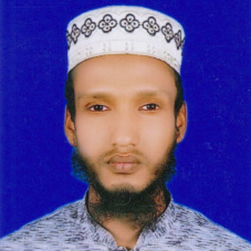
CURRICULUM VITAE
of
Md. Shahidul Islam
Kamarpara, Uttara.
Cell: 01932 742355
Email:sajibsardar4207@gmail.com

Objectives:

Experience:

Academic Qualifications

Career Objectives

To acquire a suitable position, which facilities favorable environment and self-development opportunity. Self-motivated, self driven, creative energetic with proactive attitude and willing to perform my duty with responsibility.

- Work as a Site Engineer. With Compromise Holdings Ltd.
Farmgate, Dhaka-1208. From 02nd Feb 2016 to 30th Sep 2017.

- Work as a Site Engineer . with Jamuna Chemical (Private)
Kamarpara, Uttara. From 03rd Oct 2017 to till now.

Details Academic Background

B.Sc in Civil Engineering
European University Of Bangladesh, Dhaka
Group : Civil Engineering,
Result: 3.43 (Out of 4.00)
Passing Year: 2019.

Diploma in Engineering
Bhola Polytechnic Institute, Bhola
Under Bangladesh Technical Education Board, Bangladesh.
Group: Civil Engineering, Result: 3.57 (Out of 4.00)
Passing Year: 2015

S.S.C
Shahzadpur Pilot High School, Sirajgonj (VOC)
Under Bangladesh Technical Education Board, Bangladesh.
Group: Electrical, Result: 4.92 (Out of 5.00)
Passing Year: 2011

Additional Personal Information

Personal Information:

Certificate Name : Md. Shahidul Islam
Father’s Name : Md. Abdus Salam
Mother’s Name : Mst. Shefali Khatun
Date of birth : 03/11/1996
Martial Status : Unmarried
Religion : Islam
Home District : Sirajgonj
Nationality : Bangladeshi (By birth)

Permanent Address:
Vill: Ultadab, P.O: Porjona
P.S: Shahzadpur, Dist: Sirajgonj
Rajshahi, Bangladesh.

Present Address:
Kamarpara Uttara
Dhaka, Bangladesh.

Computer Skill:
> MS Word, MS Excel, Internet Browsing, Auto CAD & Work with Basic Operating, ETABS, REVIT Architecture etc.

Communication Skill:
> Good Command in both written & Spoken Bengali, & English.

Thank you


___________
Md. Shahidul Islam

