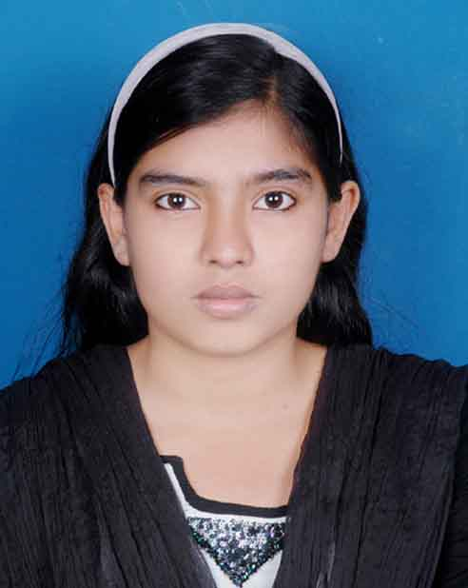
RESUME___
___Of
Tasnia Akter Binty
- Contact | : | 01914-903828, 01626-865997
E-mail : tasfia1820@gmail.com

- Objective :-
To Achieve a dynamic & challenging job in, Computer Sector and face the challenge of time and in process gain experience & skill for a successful career.

- Education: -
Diploma Eng. | : | Tangail Polytechnic Institute, Tangail.
 |  | Board | : | BTEB.
 |  | Department | : | Computer
 |  | Passing Year | : | 2017.
 |  | Result | : | CGPA- 3.54 (Out of 4.00).
S.S.C | : | Shaheed Jahangir High School.
 |  | Board | : | Dhaka.
 |  | Group  Passing Year | : | : Science.  2012.
 |  | Result | : | GPA- 4.56

- Technical Skills & Experience:-
Operating system : Win 7, 8.1, 10
Application : Ms. Word, Ms. Excel, Ms. Access,
Ms. PowerPoint

Name of Training : Web Design, Graphics Design, CIW
Experience :1 year as a computer operator.
- Training :-
Industrial Attachment | : | New Horizons CLC of Bangladesh

- Language Ability :-
Native language (Bangla) | : | Excellent in reading, writing, speaking and understanding.
Second language (English) | : | Understanding & Workable Knowledge.

  - Personal Information :-
Father’s Name | : | Late. Tofayel Ahmed.
Mother’s Name | : | RoksanaParvin
Present Address | : | Vill: Beradoma, P.O.: Dighulia,  Upz: Tangail Sadar, Dist: Tangail
Permanent Address | : | This above
Date of Birth | : | 19th August, 1997.
Sex | : | Female.
Marital Status | : | Single.
Nationality | : | Bangladeshi (By birth).
Religion | : | Islam
Blood Group | : | B(+ve).

- Reference :-

Mohammad Rakibul Hasan Md. ShamsulAlam
Jr. Instructor(Electronics Tech.) Head Teacher
TangailPolytechnic Institute Shaheed Jahangir High School
Tangail. Beradoma, Tangail
Mobile: 01918-534161 Mobile:01716-796889

I hereby declare that all information provided above belong to me and are true.

Tasnia Akter Binty

