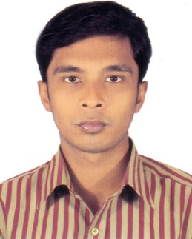
RESUME OF

REZWAN HOSSAIN
Mailing Address:
Vill: Pulerhat Berbari, P.O: Chanchra-7402,
P.S: Kotwali, Dist: Jashore
Mobile: 01824 671 961

CAREER OBJECTIVE:

I would like to have an opportunity to be employed in such a position where I can use my professional interpersonal skills in order to develop my career and as well as to contribute the welfare of the organization.

Experience
◘ Company Name : Dhaka BJIT Group
Designation : Office Assistant Cum Computer Operator
Time : 1st January, 2018 to till now.

Personal Information
◘ | Name | : | Rezwan Hossain
◘ | Father's Name | : | Md. Maruf Hossain
◘ | Mother's Name | : | Mazeda Begum
◘ | Date of Birth | : | 20-09-1997
◘ | Nationality | : | Bangladeshi
◘ | Religion | : | Islam
◘ | Sex | : | Male
◘ | Height | : | 5 feet 7 inch
◘ | Weight | : | 62 kg
◘ | National ID No. | : | 510 562 3234
◘ | Marital Status | : | Unmarried
◘ | Blood Group | : | B+

Permanent Address
Vill: Pulerhat Berbari, P.O: Chanchra-7402,
P.S: Kotwali, Dist: Jashore

Language Skills
◘ English: Good In English Speaking, Excellent In Reading & Writing.
◘ Bangla: Excellent In Speaking, Reading & Writing.

Educational Background

◘ | Examination Name | : | Higher Secondary Certificate (H.S.C)
◘ | Passing Year | : | 2016
◘ | Institution | : | Cantonment College, Jessore
◘ | Group | : | Humanities
◘ | Board | : | Jessore Board
◘ | Result | : | GPA 4.33 (Out of 5.00)

◘ | Examination Name | : | Secondary School Certificate (S.S.C)
◘ | Passing Year | : | 2013
◘ | Institution | : | Pulerhat Secondary School, Jessore
◘ | Group | : | Business Studies
◘ | Board | : | Jessore Board
◘ | Result | : | GPA 4.25 (Out of 5.00)

Interpersonal Skill
* Willingness To Learn & Work Hard.
* Productive Thinking.
* Always Positive Attitude.
* Good Communication
* High Supervision Ability.

Computer Skills
◘ Ms Word, Ms Excel, Internet, E-mail.

DECLEARATION

I certify that to the best of my knowledge, the information provided in my CV is accurate and complete.

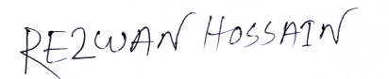

...................................
Rezwan Hossain

Date:.......................

