Curriculum Vitae of
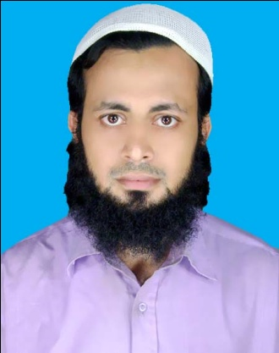
Mohammad Ridwan Khondokar
Contact Address
C/O- Hazi Yakub Khondoker
259, Abdul Hamid Road,
Sholakbahar, Panchlaish, Chittagong.
Cell: 01937909432, 01849260210.
E-mail: md.ridwankhondoker@yahoo.com
md.ridwankhondoker@gmail.com

Career Objective:
To develop myself according to my educational background & Skills. I am always keen to achieve the goals of the organization with full honest effort & responsibility.
Present Employment:
Currently serving as Accounts Officer at Somatec Pharmaceuticals Ltd. My present job responsibility includes to maintain treasury & assisting head office team in maintaining Books of accounts for Cox’s Bazar Region.

Educational Qualification:
Name of Exam | Passing Year | Group/Subject | Total Point | Board/Collage
S.S.C | 2001 | Business Studies | 3.13 | Chittagong
H.S.C | 2004 | Business Studies | 1.8 | Govt City Collage
B.B.S | 2012 | Business Studies | 505 | Govt City Collage
M.B.S(Private) | 2015 | Accounting | 2nd Class | Haji Md Mohsin Collage

Personal Information:

Name : Mohammad Ridwan Khondoker
Father’s Name : Hazi Yakub Khondoker
Mother’s Name : Mrs, Sayeda Marium Begum
Date of Birth : 19/12/1985
Religion : Islam.
Nationality & ID No. : Bangladeshi by birth, 1595708508474.
Gender : Male
Marital status : Unmarried
Cell Phone : 01937909432, 01849260210.
Permanent address : C/O- Hazi Yakub Khondoker
259, Abdul Hamid Road,
Sholakbahar, P.S- Panchlaish,
Dist: Chittagong.
Present Address : Same as above.

Past Experiences : I have been working in the field of Real Estate Sector for 4 Years & 1 year Stock Lot dealings with buying firms in earlier years.

Other Skills : Office Programs like MS word, excel etc & Internet Browsing ,Search Engine Optiming(SEO), Online Advertising,
Social Media Marketing (SMM),
Map Maker, Web Content, Website create,

Hobbies : Reading Books & Stamp Collection.
Language Skills : Familiar to communicate in English, excellent in Bangoli.

References:
1. Mr.Sayed Jamil Ahmed
Senior Merchandiser
Four-H-Group
Chittagong.
Cell: 01764144420.

2. Mr. Ahmed Romman Shamsi
GM Audit & Company Secretary
KDS Group
Nasirabad I/A, Chittagong
Cell: 01713 197171

Signature & Date

(Mohammad Ridwan Khondoker)

