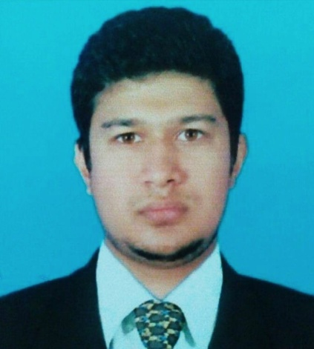
Rabby Hossain
Present address:
House#132/7 Nogorpara, P/O: Joydepur
P/S: Gazipur Sadar District: Gazipur-1702
Mobile No: 01918328524, 01616784111
E-mail:rabbyhossain552@gamil.com
PERSONAL INFORMATION

Name : Rabby Hossain
Father Name : Md. Abu Sayed
Mother Name : Akhi Begum
Permanent Address : House#132/7 P/O: Joydepur, P/S: Gazipur Sadar, District: Gazipur-1702
Date of Barth : 19-10-1994
Nationality : Bangladeshi
Religion : Islam
Marital Status : Single
Blood Group : A+
National Id No : 5054762140

ACADEMIC QUALIFICATION
Degree | Subject | University / College/School | Passing Year | Result | Out Of
SSC | Business Studies | Salna Nasiruddin Memorial School | 2009 | 2.88 | 5.00
HSC | Business Studies | Bhawal Bodre Alam Govt. College | 2011 | 3.10 | 5.00
BBA | Management | National University | 2016 | 2.97 | 4.00
MBA | Management | National University |  | Result expected

PROFESSIONAL QUALIFICATION
Course | Awarding Body | Subject | Year
Microsoft Office Program | A- | Microsoft Office, Excel, PowerPoint, Processing Email, Web Browsing ,Adobe Photoshop ,Etc | 2016

OTHER INFORMATION
Proficiency In English | Reading : Excellent | Writing : Good | Speaking : Good
Academic Distinction:
S@IFUR’S Chandona Chowrasta Branch.

Any Other Think You Disclose:
- Hard working
- Disciplined & time conscious
- Effective team player
- Have good presentation skill
- Quick and contingent decision maker

REFERENCE INFORMATION
1. Name: Md. Murad Mahamud
Position: Lecturer
Company Name: Gazipur Model College.
Address: Chandona, Gazipur
Phone: +88 01859839960
Email: mmahamud546@gmail.com
Relation: Relative

2. Name: Samima Akter
Position: Lecturer
Company Name: Gazipur Model College
Address: Chandona, Gazipur
Phone: +8801825581774
Email: samimaa462@gmail.com
Relation: Relative

Declaration:
I hereby declare that the above mentioned details are true to the best of my knowledge.

