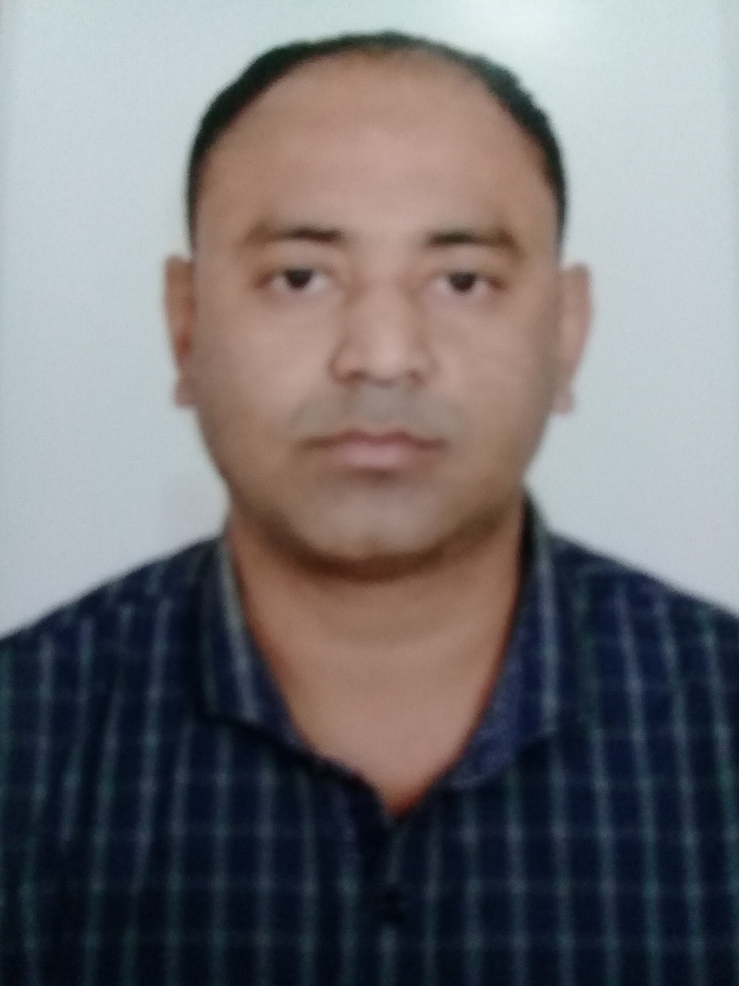

SEAFARER EMPLOYMENT APPLICATION FORM

POST APPLIED FOR : CH. OFFICER

(Please read form carefully before attempting to fill in, where not applicable state “N.A.”. Copies of certificates/testimonials etc. should be attached to the form.)

Agency Name :

A) Type of vessel applying for : (Plase Tick)
Tanker (20000 DWT) GP Tanker (< 20000 DWT) Bunker Barge

(I) PERSONAL PARTICULARS

Last/Surname Name ISLAM/ RAISUL |  |  |  |  |  |  | Given Names (as in passport)  SYED RAISUL ISLAM
Present Address:  Aladatpur, Narial,Jessore,Bangladesh. |  |  |  |  |  |  | Email: raisulatocean@gmail.com  Skype ID: raisul.islam |  |  |  |  |  |  |  | Shoe Size:41 |  |  | Overall Size:XL
Phone No:(Country Code)+(Area Code)+(Tel No) |  |  |  |  |  |  | Mobile No:(Country Code)+(Area Code)+(Mobile No)  +88-01796485468 / +88-01710900200
Date of Birth  01/07/1982 |  | Place and Country of Birth  JESSORE, BANGLADESH |  |  |  |  | Nationality  BANGLADESHI |  |  |  |  | Religion  ISLAM |  |  |  | Marital Status  MARRIED
( II ) FAMILY BACKGROUND

Next of Kin  Syeda Tasnim Ariq |  |  |  |  | Relationship(Husband/Wife if married;Father/Mother/Guardian if single)  Wife
Address of Next of Kin: Aladatpur, Narial,Jessore, Bangladesh.
Telephone No : |  |  |  | Mobile Phone No :+88-01753765753 |  |  |  |  |  |  |  |  |  | Email : raisulatocean@gmail.com
Children’s Name (if applicable) |  |  |  |  |  |  |  | Sex | Age |  | Occupation
1) Syed Ayeat Bin Raisul |  |  |  |  |  |  |  | M | 1Y
2)
3)
(III) HIGHEST ACADEMIC QUALIFICATION

From | To |  | Institutions/Universities attended |  |  |  |  |  |  |  | Qualifications
1999 | 2001 |  | M.M. UNIVERSITY |  |  |  |  |  |  |  | BSC
2002 | 2004 |  | ISLAMIC UNIVERSITY &TEC |  |  |  |  |  |  |  | MBA (SHIPPING MARKETING)
(IV) DOCUMENTS AND CERTIFICATES

Personal Document |  |  |  |  |  | Document No. |  |  |  | Issue Date |  |  | Expiry Date |  |  |  | Issued by
International Passport with 2 blank page |  |  |  |  |  | BN 0214640 |  |  |  | 26/01/2017 |  |  | 25/01/2022 |  |  |  | DIP / DHAKA
Seaman Passport (If Any)
Discharge book (CDC) |  |  |  |  |  | C/O/5123 |  |  |  | 21/12/2017 |  |  | 20/12/2027 |  |  |  | SHIPPING OFFICE, CTG
STCW Certificate
Certificate Of Competency (COC)  Indicate Grade : _Class- 1 DECK |  |  |  |  |  | BD1007848 |  |  |  | 15/10/2017 |  |  | 14/10/2022 |  |  |  | D.G Shipping Bangladesh
COR MALAYSIA |  |  |  |  |  | 23127028DI |  |  |  | 06.09.18 |  |  | 05.09.19 |  |  |  | Malaysia Marine Dept.
ID MALAYSIA |  |  |  |  |  | 200923007113 |  |  |  | 04.09.18 |  |  | 03.09.19 |  |  |  | Malaysia Marine Dept.
General Operators Certificate (GOC) : (Deck Officers only) |  |  |  |  |  | GMDSS-003225 |  |  |  | 24/05/2017 |  |  | 23/05/2022 |  |  |  | D.G ShippingBangladesh
PST |  |  |  |  |  | 039.038634 |  |  |  | 25/01/2017 |  |  | 24/01/2022 |  |  |  | IMTA
PSSR |  |  |  |  |  | 042.038637 |  |  |  | 25/01/2017 |  |  | 24/01/2022 |  |  |  | IMTA
Tanker Familiarization (Oil/Chemical/Gas Tanker) |  |  |  |  |  | 046.038717 |  |  |  | 26/06/2017 |  |  | 25/06/2022 |  |  |  | IMTA
Advance Oil Tanker |  |  |  |  |  | 051.037384 |  |  |  | 25/11/2016 |  |  | 24/11/2021 |  |  |  | IMTA
Advance Chemical Tanker |  |  |  |  |  | 053.037403 |  |  |  | 25/11/2016 |  |  | 24/11/2021 |  |  |  | IMTA
Ship Board Safety Officer |  |  |  |  |  | BDSBSO-003317 |  |  |  | 18/09/2017 |  |  | 17/09/2022 |  |  |  | IMTA
Proficiency in Survival Craft and Rescue Boat Other Than Fast Rescue Boat |  |  |  |  |  | 043.038755 |  |  |  | 27/02/2017 |  |  | 26/02/2022 |  |  |  | IMTA
Advance Fire Fighting |  |  |  |  |  | 045.038437 |  |  |  | 26/06/2017 |  |  | 25/06/2022 |  |  |  | IMTA

Elementary First Aid |  | 041.038632 |  | 25/01/2017 | 24/01/2022 | IMTA
Medical Care On Board |  | 043.038748 |  | 24/07/2017 | 23/07/2022 | IMTA
Ship Security Officer |  | 047.038442 |  | 26/06/2017 | 25/06/2022 | IMTA
Security Awareness Training |  | 049.038743 |  | 25/01/2017 | 24/01/2022 | IMTA
Seafarers with Designated Security Duties |  | 050.038748 |  | 25/01/2017 | 24/01/2022 | IMTA
Ship Handling Certificate (For Master) |  | 050.027438 |  | 18/09/2017 | 17/09/202 | IMTA
ECDIS Training Certificate |  | 059.038457 |  | 18/09/2017 | 17/09/2022 | IMTA
Bridge Team Management |  | 061.032732 |  | 24/07/2017 | 23/07/2022 | IMTA
Bridge Resource Management |  | 063.032741 |  | 24/07/2017 | 23/07/2022 | IMTA
Fire Prevention &Fire Fighting |  | 040.038638 |  | 25/01/2017 | 24/01/2022 | IMTA
Ship Simulator &Bridge Team Work |  | 031.032971 |  | 24/07/2017 | 23/07/2022 | IMTA
RADER, ROC ARPA (Operation Level) |  | 053.038224 |  | 27/02/2017 | 26/02/2022 | IMTA
RADER,ROC ARPA (Management Level) |  | 053.038378 |  | 26/06/2017 | 25/06/2022 | IMTA
Specialiazed Tanker Training Course Chemical |  | BDAC- D 0001944 |  | 25/11/2016 | 24/11/2021 | Department Of Shipping  Dhaka
Specialiazed Tanker Training Course Oil |  | BDAO- D 0001862 |  | 25/11/2016 | 24/11/2021 | Department Of Shipping  Dhaka
MARITIME ENGLISH COURSE (MEC) |  | MEC/1722/07 |  | 28/12/2017 | 27/12/2022 | IMTA
Medical Examination (MLC )
Yellow Fever
Cholera Vaccination
(V) DETAILS OF SPECIAL TRADE * delete whichever is not applicable
Experience on Inert Gas Tanker: YES / * |  |  | Experience on Chemical Tanker: YES
Experience with USCG (TVEL): YES / NO* |  |  | Experience on STS: YES
 | PSC Experienced: YES Vetting Inspection Experienced: YES
 | Trading Area: WORLD WIDE
Types of Cargo experience With: MGO, DPK, JET A-1, PMS, ULG95, ULG 97, VARIOUS PLAM PRODUCT OIL, HFO RMG 180, CST 180, RMG360, CST360 & NAFTA OTHERS….

CHEMICAL
 | Experience with Nationalities : INDIA, MIYANMA, MALAYSIA, INDONESIA, CHINA, UKRINE,
 | FILIPINO, THAILAND, PAKISTAN, JAPANESE, KOREAN, NAIGERIA, GHANA, ETC….

(VI) ADDITIONAL INFOMATIONS
Command of English | VERY GOOD

(VII) DETAILS OF SEA SERVICE

Company | Vessel | Vessel |  | GRT | Type of | BHP/ | Rank | Period |  | Total
 | Name | Type |  |  | Engine | KW |  | From | To | Months
ALPHA VANGARD SIN | MV. MARIS |  | BULK | 20854 |  |  | D/C | 12/2/2005 | 5/10/2005 | 7M
ALPHA VANGARD SIN | MV. MARIS |  | BULK | 20854 |  |  | D/C | 30-01-2006 | 10/12/2006 | 10M
SHIP MANAGEMENT  LTD | MT. GOLDEN SUNRISE |  | OIL TANKER | 12691 |  |  | D/C | 11/1/2007 | 14/07/2007 | 6M
FAREAST SHIP  MANAGE | MT. FAIR ENERGY |  | OIL TANKER | 28610 |  |  | 3/O | 15-12-2007 | 11/8/2008 | 7M
FAREAST SHIP  MANAGE | MT. FAIR ENERGY |  | OIL TANKER | 28610 |  |  | 2/O | 14-01-2010 | 7/7/2010 | 5M
ACCORD SHIPPING | MT. SEA VOYAGER |  | OIL PRODUCT TANKER | 4176 |  |  | 2/O | 20/10/2010 | 18/03/2011 | 5M
ACCORD SHIPPING | MT. SEA VOYAGER |  | OIL PRODUCT TANKER | 4176 |  |  | C/O | 19/03/2011 | 19/07/2011 | 4M
GULF ENERGY MARITIME | MT. GULF ESPRIT |  | CHEMICAL TANKER | 29490 |  |  | C/O | 22/01/2012 | 2/5/2012 | 4.5M
EA TECHNIQUE  SDN BHD | MT. NAUTICA BATU PAHAT |  | OIL PRODUCT TANKER | 7626 |  |  | C/O | 10/10/2012 | 09/12/2012 | 2.5M
EA TECHNIQUE  SDN BHD | MT. NAUTICA MAHARANI |  | OIL PRODUCT TANKER | 7604 |  |  | C/O | 12/16/2012 | 19/06/2013 | 6M
GULF ENERGY MARITIME | MT. GULF ELAN |  | CHEMICAL TANKER | 29490 |  |  | C/O | 5/01/2014 | 20/07/2014 | 7M
MAY MARITIME SDN BHD | MT. WIN ONE |  | CHEMICAL TANKER | 4355 |  |  | C/O | 12.03.2015 | 23.09.2015 | 6M
MAY MARITIME SDN BHD | MT. WIN ONE |  | CHEMICAL TANKER | 4355 |  |  | C/O | 02.01.2016 | 21.05.2016 | 6M
MAY MARITIME SDN BHD | MT. WIN TWO |  | OIL /CHEMICALTANKER | 2043 |  |  | MASTER | 18.02.2018 | 25.10.2018 | 8 M
(VIII) MEDICAL HISTORY / BACKGROUND
* delete whichever is not applicable
Height : 5'8'' Weight:75KG Chest Span : |  | 39’’
a) | Do you have any history of family or personal illness such as Tuberculosis, High Blood Pressure, and Mental Illness etc? | No*  Yes/No*  Yes/No*  Yes/No*  Yes/No*
b) | Have you ever been hospitalised, operated or currently undergoing some kind of medical treatment? | No*
c) | Do you have an emotional or physical handicap (disability)? | No*
d) | Have you ever been charged in court for any offence? | No*
e) | Have you been involved in a maritime incident before? | No*
 |  | No*
If any of the answer is “Yes”, please give details below

(IX) DECLARATION BY APPLICANT

I certify that all statements given on this application are correct and true to my knowledge. I also understand that falsification or misrepresentation ( intentionally or unintentionally ) in this or any other personnel records can result in my immediate dismissal and forfeiture of all wages, allowances and benefits if I am employed by the Company. I do agree to submit myself to a thorough medical examination, which I must successfully pass as one of the conditions for being accepted for employment.

SYED RAISUL ISLAM
Signature of Applicant / Date

