Curriculum Vitae of
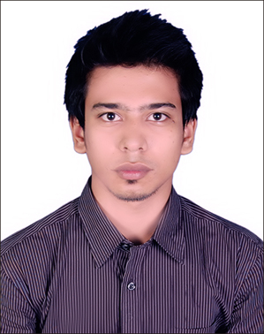
Abdullah Al Rayan

Mailing Address :

House#48, Road-01, Block#E,
Eastern Housing,Pallabi, Mirpur-12, Dhaka-1216.

Cell :+8801672-711121
E-mail : raiyan.khan35@gmail.com

Career Objectives :

Looking for a hard and challenging job where I will have the scope to utilize my potentiality, adaptability and skill to do something innovative and form where I will be able to enhance my knowledge.

Educational Qualification :

Bachelor of Business Administration (BBA)
Under : National University
Institute : Model Institute of Science And Technology (MIST),Gazipur.
Major Subject : Finance
Result : 2.95 Out of 4.00
Year of Passing : 2019
Higher Secondary School Certificate (H.S.C)

Under : Dhaka Board
Institute : Dhaka Commerce College
Group : Commerce
Year of Passing : 2014
Result : 4.80 Out of 5.00
Secondary School Certificate (S.S.C)

Under : Dhaka Board
Institute : Green Field School & College
Group : Commerce
Year of Passing : 2012
Result : 4.56 Out of 5.00

JOB EXPERIENCE :

Organization Name : Aarong (Outlet : Mirpur)
Designation : Sales Associate
Period : About 45Day’s (EidPackage)

Organization Name : Jamuna Future Park (Show Room: Ecstasy)
Designation : Sales Executive
Period : About Two Month

Organization Name : Bashundhara City (Show Room: Doors)
Designation : Sales Executive
Period : About 40 Day’s (Eid Package)

COMPUTER SKILLS :

- Word Processing : Microsoft Word.
- M.S : Power Point.
- Internet : Browsing, E-mail, Download, etc.

Other Skills

- Good Communication Skill
- Good Team Worker
- Leadership Experience
- Time Efficient Worker

Language Skill :

Language | Speaking | Reading | Writing
Bengali | Excellent | Excellent | Excellent
English | Excellent | Excellent | Excellent

Interest :

- Finance,
- Banking,
- Accounts.
- Administration
- Management etc.

Personal Information :

Name : Abdullah al Rayan
Nick Name : Raiyan
Father’s Name : A.B.M. Hafizul Islam
Mother’s Name : JasminNasima
Date of Birth : 31st July, 1997 (As S.S.C Certificate)
Religion : Islam
Marital Status : Unmarried
Sex : Male
Nationality : Bangladeshi (By Birth)
Height : 5'7"
Weight :64kg
Present Address : House#48, Road-01, Block#E,
Eastern Housing,Pallabi, Mirpur-12, Dhaka-1216.

Permanent Address : Same As Above

Self-Appraisal :

- Honest and Punctual
- Pro-Active
- Committed to achieving targets.
- Quick Learner and analyzer
- Good as a team member.
- Dedicated.
- Self-Motivated
- Innovative
- Like to take the challenge.
- Hard Working and energetic.
- Steadfast
- Amiable and Friendly.
- Trustworthy.
- Loyal
- Able to Measures Performance.

Hobbies:

Listening Music, Watching TV & Travelling,
Declaration :

I confirm that to best of my knowledge the information given herewith is true, authentic and up-to date.

ABDULLAH AL RAYAN
Signature & Date

