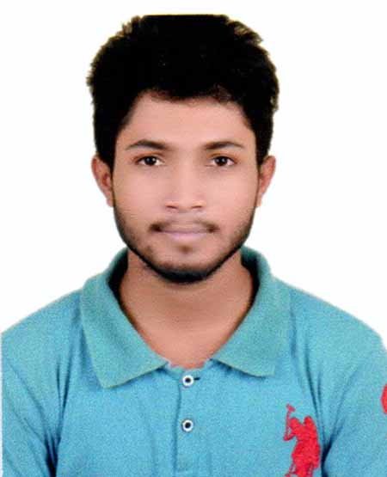
RESUME
Of
Cironjit Das
01721769199
natural.srijon261298@gmail.com
Objective:
To build up career in challenging and rewarding position at a wining organization where creativity and performance are the criteria for one’s appraisal and recognition.

Contact details:

01. Name : Cironjit Das
02. Father’s name : Dhirendra Kumar Das
03. Mother’s Name : Kamala Rani Das
04. Date of birth : 26/12/1997
05. Age : 19 Years

06. Present address : College Road,Chhatak,Sunamgonj

07. Permanent address : College Road,Chhatak,Sunamgonj
P.O:Chhatak,P.S:Chhatak,
District:Sunamgomj
08. Home Districts : Sunamgonj
09. Marital Status : Unmaried
10. Nationality : Bangladeshi
11. Religion : Hindu
12. Height : 5 Feet 3.5 Inches
13. Educational Qualification

Exam Title | Concentration/Major | Board Name | Result | Passing Year | Duration
HSC | Bussiness Study | Sylhet | 4.00(out of 5.00) | 2016 | 2 Years
SSC | Bussiness Study | Sylhet | 5.00(out of 5.00) | 2014 | 2 Years

Reference :
E- Strengths:

I am an energetic, dynamic and of personality, responsibility and have skills to work own initiative in all atmospheres.
Computer Skills:
- MS Word, Excel, Power Point.
- E-mail.
- Internet Browsing.
Proffesional Skills:
- Organaized Person
- Magazine Writter
- Theatre
- Anchor
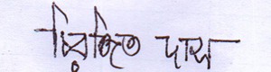 Signature of applicant

