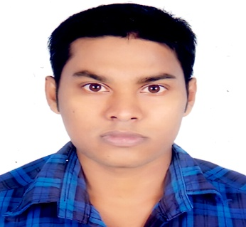
Resume
Of
RAJENDO SHEKHAR DASH
Mailing Address  Mobile No.  Email: | C/O-Bhupika Ranjan Dash  Angura Tower (3rd Floor),  Ahsania Mission  Habiganj Municipality  Habiganj-3300  01714 293 507  rajendoshekhar@gmail.com
OBJECTIVE: | I want to set an example in the organization through my creativity, honesty & sincerity, where strong sense of responsibility, equal opportunity & willingness to learn and grow are valued characteristics and a good or friendly environment is provided to work spontaneously that will lead are to be skilled. Serve the people to serve the nation.
EXPERIENCE | Having working experience of 1year as a Assistant Teacher in Heaven Touch School, Habiganj.
EDUCATION:
B.B.A(Hon’s)  H.S.C.  S.S.C | 2015  Brindaban Govt. College, Habiganj.  National University  Major in Accounting  C.G.P.A - 3.00 out of 4.00  2011  Brindaban Govt. College, Habiganj.  Sylhet Board  4.10 (Out of 5.00)  Business studies  2009  Habiganj Govt. High School  Sylhet Board  4.56(Out of 5.00)  Business Studies

Computing Skills: | - Familiar with MS Office Management  - Internet Essentials, E-mail

Language: | - Bengali : Mother Language  - English : Moderate

Interest & Hobbies: | Hobbies are Playing Cricket, Reading Books, Travelling, Kung-fu etc.
Personal Details:
Name:  Father’s Name:  Mother’s Name:  Date of Birth:  Nationality:  Gender:  Marital Status:  Religion  Permanent Address: | Rajendo Shekhar dash  Bhupika Ranjan dash  Nioti Rani dash  1st January,1992  Bangladeshi  Male  Single  Hindu  Angura Tower (3rd Floor),  Ahsania Mission  Habiganj Municipality  Habiganj-3300
REFERENCE:
Dr. Shovendo Shekhar Dash
M.B.B.S, B.C.S (Health), M.D
Medical Officer
Rangpur Medical College & Hospital.
Mobile: 01750-794280

I, the undersigned certify that according to my knowledge and belief. This CV correctly describes my qualification and myself. I understand that any willful misstatement describes my lead to disqualification or dismissal, if employed.

-----------------
Signature
Date:

