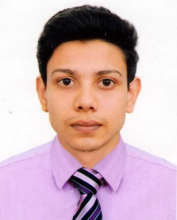
CURRICULUM VITAE
OF
RAJIB KANTI DEB
Contact Address:

Vill: PurboModongouri, P.O: Elahigonj, P.S: Golapgonj, Dist: Sylhet-3100
Cell: 01724011577

CAREER OBJECTIVE:

Build up a challenging and rewarding career in an organization that provides structured career advancement with in the extent of competitive and dynamic service environment and face challenging opportunities with sincerity, punctuality, commitment, self-competency and hard work.

EDUCATIONAL QUALIFICATION:

Degree
University : National University
Institute : Sylhet Govt. College.
Subject : B.S.S
Year : Running (3rd Year)
Result : Pending

Higher Secondary Certificate (H.S.C)

Institute : Madan Mohan College.
Passing Year : 2013
Board : Sylhet
Group : Humanities
Result : GPA (4.50)

Secondary Certificate (S.S.C)

Institute : Purbo Renga High School.
Passing Year : 2011
Board : Sylhet
Group : Humanities
Result : GPA (3.50)

LANGUAGE SKILLS:

A smooth fluency in speaking, Writing both in Bangla and English as a second language, and able to contact excellent

Interested : Reading Book,
Hobbies : Gardening

COMPUTER LITERACY:
MS Word, MS Excel & Internet Browsing.

PERSONAL INFORMATION:

- Name : Rajib Kanti Deb
- Father’s Name : Sushil Chandro Deb
- Mother’s Name : Jorna Rani Deb
- Permanent Address : Vill: PurboModongouri, P.O: Elahigonj,
P.S: Golapgonj, Dist: Sylhet-3100
- Date of Birth : 12 April 1995
- Birth Place : Sylhet
- Gender : Male
- Marital Status : Unmarried.
- Nationality : Bangladeshi (By Birth)
- Religion : Hindu

EXPERIENCE:

- I have been working as a Robi Sales Supervisor Running.
- I have been working as a Promoter Tecno Mobile in 1.5 Year.
- I have been working as a Promoter Lava mobile company in 2 years.

Reference:

Rajib Kanti Deb

Date:.........................

