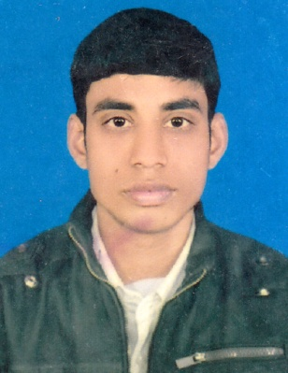
Resume
Of
MD. RAJU HOSSAIN
Contrct Address: Jagdishpur, Jamalgonj,
Badalgachhi, Naogaon
Cell: +8801738-088556
E-mail: razua9770@gmail.com

Career Objective
To enter into an organization where I could use my educational knoweledge and skill to strengthen my future professional career as well as contribute to people of Bangladesh to add am fully confident that I will be able to perfrom according to desire criteria and hope my contibution eill be apperciated to growth your organization and build up my career.

Educational Qualification

Bachelor of Business Studies (B.B.S pass)
Institute : Joypurhat Govt. College, Joypurhat
University : National University
Year of Passing : 2015
Result : 2nd class
Higher Secondary Certificate (H.S.C)
Institute : Jamalgonj College,
Board : Rajshahi
Result : GPA- 3.80 (Out of 5)
Group : Business Studies
Year of Passing : 2012

Secondary School Certificate (S.S.C)
Institute : Jamalgonj High School
Board : Rajshahi
Result : GPA- 3.63 (Out of 5)
Group : Scince
Year of Passing : 2010

Language Proficiency

Efficient and skilled in Writing and Reading all forms of business correspondences and Good speaking Fluency in Bengali as well as English with good pronunciation.

Computer Skill

Expertise in MS Word, Excel, Power Point, Internet, Access.
Experience:

Name of Company | Designation | Duration
P.K.S.F Fashion Ltd. | Distributor | 02 Year
L-usine Fashion Ltd.(Unit-1) | Senior Distributor | 1 Year
R.G.R Sweater Ltd. (Moni Group) | Distributor In-charge | 2 Year
Hannan Knit & Textile (Hannan Group) | Distributor In- charge | 2 Year
L-usine Fashion Ltd.(Unit-1) | Senior Distributor | 02-04-2018 to till now

Interest & Information:

Social Service
Reading
Traveling & Music

Personal Information

1. Name : Md. Raju Hossain

2. Father’s Name : Md. Khairul Islam

3. Mother’s Name : Anjuara Begum

4. Permanent Address : Vill: Jagdishpur, P.O: Jamalgonj,
P.S: Badalgachi. Dist: Naogaon.

5. Present Address : Vill: Jagdishpur, P.O: Jamalgonj,
P.S: Badalgachi. Dist: Naogaon.
6. Date of Birth : 09/04/1992
7. Religion : Islam.
8. Marital Status : Unmarried
9. Nationality : Bangladeshi (By Birth)
10. Sex : Male
11. Height : 5 feet 5 inch
12. National ID No : 19926410652000068
13. Contract Number : 01738-088556
14. Blood Group : A+

Date:..................... Signature

(Md. Raju Hossain)

