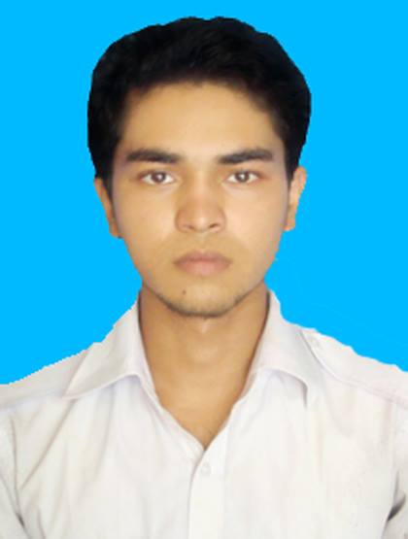
Ram Chandro
Phone: 01763298868  sourovsarker8750@gmail.com | House#58, Staff Quarter  Dhanmondi 15, Dhaka-1209

Education

BSC Daffodil International University, Computer Science Engineering Still Studying
Level One: Semester Two.

HSC Lalmonirhat Govt. College July, 2017
Result: 3.67 (out of 5)
Background: Science

SSC Lalmonirhat Govt. High School May 2015
Result: GPA 4.33 (out of 5)
Background: Science
Experience

- Worked as a Salesman in Basundhara Collections, Lalmonirhat for 5 months.
- Work in Travelers of Daffodil International University

Languages

English: Intermediate Listener, Novice Speaker, Advanced Reading and Writing.

Bangla: Native Language

Computer Skills

Programming: C
Applications: Microsoft Word, Microsoft Excel, Photoshop, Camtasia, Microsoft PowerPoint.

Platforms: Facebook, Instagram, Twitter, Musical.ly, YouTube

Other
Hobby: Video editing, Reading books.

Citizenship: Bangladeshi (by born)

References

