CURRICULUM VIATE OF
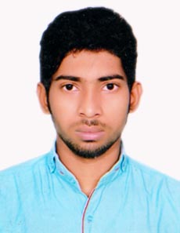

MD. RASEL BHUIYAN

Mailing Address:

1/D/6/A, Mirbagh, Moghbazar,
Ramna, Dhaka-1217.
Cell: 01910-077511
Email: rasel.rjboy500@gmail.com

Career Objective:

To work in the position of Driver with a Company. Offering Extensive Knowledge of Traffic Law and Practices ability to perform minor Vehicle repairs and Excellent Services.

Academic Qualification:

Secondary School Certificate (S.S.C)
Name of Institution : UCEP Tytte Botfeldt School
Board : Bangladesh Open University (BOU)
Result : GPA-2.73 (Out of 5)
Passing Year : 2018

Job Experience:

- Total Year of Experience (6.6 Years)
- Driver ( December 12, 2016 - Continuing)
Humayun Kabir Trade
Company Location : 47/C North Begunbari, Tejgaon, Dhaka.
Department : Driving

- Driver ( March 31, 2013 – November 30, 2016)
Humayun Kabir Trade
Company Location : Rokeya Tower, Wireless, Boro Moghbazar, Dhaka.
Department : Driving

Industrial Training:

- Training on Automobile Technician at UCEP Mirpur Technical School for 01 Year.

Interest & Hobbies:

- Reading Books, Writing, Play Cricket & Football, Social Work & Traveling.

Personal Details:

Name  Father’s Name  Mother’s Name  Permanent Address  Date of Birth  Nationality  Religion  Marital Status  Height  Blood Group  Gender | Md. Rasel Bhuiyan  Md. Babul Bhuiyan  Nasrin Begum  Vill: Showjalia, P.O: Bazita,  P.S: Mirzaganj, Dist: Patuakhali.  10th November, 1992  Bangladeshi (By Birth)  Islam  Single  5'-4"  O- (Negative)  Male

Declaration:

I, hereby declare that do the best of my knowledge and belief, this information’s are true and correct, if I am appointed, I will maintain the rules and regulations of the organization.

______________
(Md. Rasel Bhuiyan)

Date:_____________

