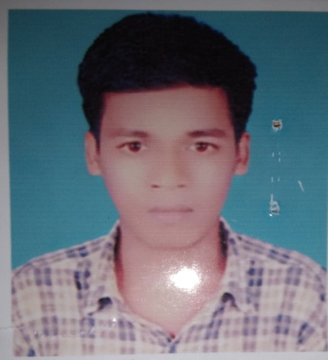
Personal Details;
Name : Sri Razon Chandra Barman
Father’s Name : Sri Jotish Chandra Barman
Mother’s Name : Sri Moti Rani Bala
Date of Birth : 03/03/1999
Present Address : Asratpur (shobuj bag) Rangpur
Permanent Address : Asratpur (shobuj bag) Rangpur
Nationality : Bangladeshi
Religion : Hindu (shonaton)
Blood Group : B+
Gender : Male
Marital Status : Unmerited
Educational Qualification ;
Name of Exams | Group | Result | Board/University | Passing Year
S.S.C | Science | 3.64 | Technical | 2015
H.S.C | Science | 3.50 | Technical | 2019

Signature
…………………….

