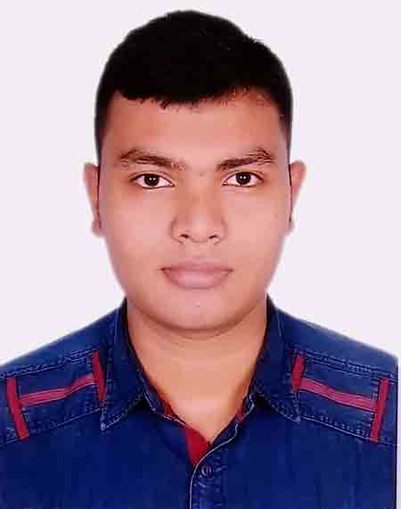
Bio-Data

1. Name : Redoy Saha
2. Father’s Name : Chinmoy Saha
3. Mother’s Name : Beauti Saha
4. Present Address : Thakurpara, Baganbari,
P.S: Comilla Sadar, Dist: Comilla.
5. Permanent Address : Thakurpara, Baganbari,
P.S: Comilla Sadar, Dist: Comilla.
6. Date of birth : 24-11-1994
7. Nationality : Bangladeshi by Birth
8. Religion : Hindu
9. Marital Status : Single
10. Contact : 01308-082469
12. Height : 5 Feet 10 Inch
13. Language : Bangla, English, Hindi.
14. Education Qualification:
Name of the Examination | Group | Grade/Davison | Year of passing | Board/University
S.S.C | Business Studies | 3.56 | 2011 | Comilla
H.S.C | Business Studies | 2.90 | 2013 | Comilla
In Diploma (Business Management) | Accounting | 2.12 (Out of 4) | 2018 | Malaysia Board

15. Working Experience: As A Sales Assistant in Marketing, EUREKA SNACK BAR in Malaysia from 01 August, 2016 to 01 August, 2018.
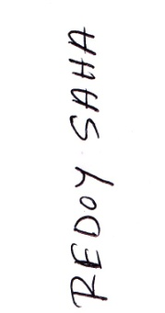

Signature: ......................................
(Redoy Saha)
Date: 04/01/2020

