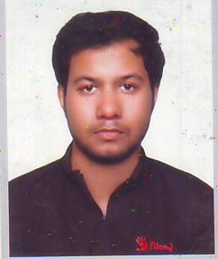
RESUME OF
Refat Iqbal Chowdhury
51/1 Iqbal Manzil, Pathantula, Sylhet.
Mobile:01723553907
E-mail: refatchy065@gmail.com

Career Objective
To work on a challenging job profile which provides an opportunity to enhance my technical skills and knowledge, this could provide me an insight into new aspects so that it would be helpful for my career.

Education:
University:
• B.Sc. Engineering in Computer Science and Engineering at Metropolitan University, Sylhet, 2013 to present.
College:
• Completed A-Level from Sylhet International School & College, Sylhet in 2012
School:
• Completed O-Level from Khadjanchibari International School & College, nayasarak, Sylhet in 2010

Technical Profile:
Programming Language : C and Java programming.
Web Technologies : HTML5, CSS3, Bootstrap, PHP, Framework (CodeIgniter ), and MySQL.
Language:
Bengali, English.
Strengths:
• I am a quick learner.
• Self-confident and patience.
• Willing to Learn.
• Analyzing every angle of a project before working on it.
• Adaptability to change environment.
• Ability to work in the team and individual.

Interests:
Programming and Online Gaming.

If you have any question I can be reached at the number mentioned above. Thank you for your attention.

