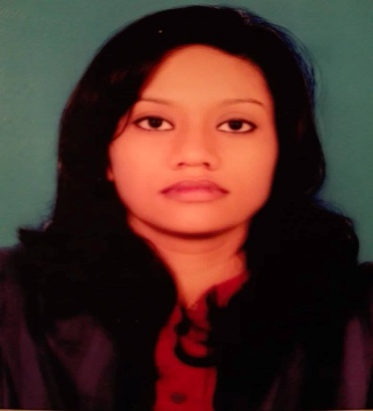
RESUME
OF
Rehnuma Jannat
Cell: +8801624257602
Mail address: rehnumajannat123@gmail.com

ADDRESS
27/5 Allahwala vaban,
Kawlar,Mollabari,
Dhakkhin khan,
DhakaMobile: +8801624257602

CAREER OBJECTIVE:

Willing to work in a career based well known organization, where success comes through creativity, hard work, sincerity and devotion to duty in achieving organizational goal as well as enriches Knowledge.

EDUCATIONAL QUALIFICATION:

Exam Title | Institution | Group | Result | Passing Year | Board
Masters in Clothing & Textile | Home Economics College |  | First Class | 2017
B.Sc in Clothing & Textile | Home Economics College |  | First Class | 2016
HSC | Shaheed Bir Uttam Lt. Anwar Girls College | Science | 5.00 | 2012 | Dhaka
SSC | Civil Aviation High School | Science | 5.00 | 2010 | Dhaka

SKILLS:

- Computer Knowledge
Computer Knowledge Operating Program: Microsoft Office 2007,
Internet Browsing, E-mailing & Communicating.

LANGUAGES KNOW:

- Bengali (Native Language) : Expert
- English : Good Command in Speaking, listening.

INTEREST

Reading Science Magazine, Traveling, Indoor & Outdoor Game, Watching Movie and browsing Internet.

PERSONAL INFORMATION:

- Name : Rehnuma Jannat
- Father’s Name : Md. Rafiqur Rahman
- Mother’s Name : Shahnaz Rahman
Present Address : 27/5 Allahwala vaban,
Kawlar,Mollabari,
Dhakkhin khan,
- Permanent : 27/5 Allahwala vaban,
Kawlar,Mollabari,
Dhakkhin khan,
- Date of Birth : 2nd January 1995
- Gender : Female
- Marital Status : Married
- Religion : Islam
- Height : 5’-5”
- Nationality : Bangladesh (by birth)

______________
Signature
Date:

