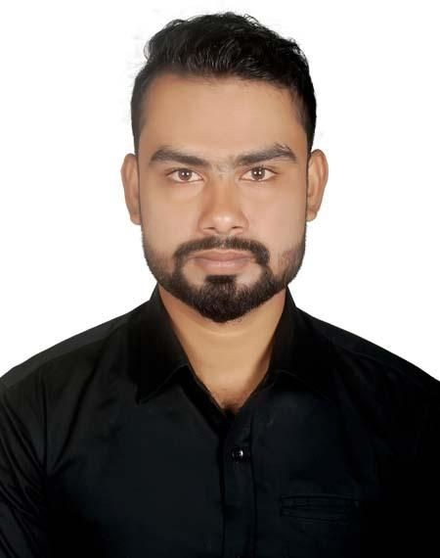
Resume of
Md. Mynul Hassan
Address: House No- 56, Konapara,
Nurani Mosjid Road, Demra, Dhaka- 1362. Cell No: 01686660451
E-mail: rk57360@gmail.com

Career Objective

I would like to work in an organization where I can use my qualifications. The job I am applying for is a good opportunity for me to work actively and productively and apply my skills. My aim is to make a difference in my work-place through my contribution. I am a self-starter and have excellent interpersonal and conflict-management skills.

Educational Qualification

Bachelor of Business Administration : Major in Finance
Institution : Stamford University Bangladesh
Result : CGPA 3.27 out of 4
year of Passing : 2018
Higher Secondary Certificate (H.S.C) : Business Studies
Institution : Dr. Mahbubur Rahman Mollah College
Board : Dhaka
Result : GPA 4.50 out of 5.00
Year of Passing : 2013

Secondary School Certificate (S.S.C) : Business Studies
Institution : Shamsul Hoque Khan School and College
Board : Dhaka
Result : GPA 4.25 out of 5.00
Year of Passing : 2011

SELF COMMITMENT
- Ability to cope up with different situations
- Co operative, innovative
- Quick learner

Computer Skill
- MS- Word, MS-Excel, MS PowerPoint, Internet Browsing,

Extra Curriculum Activates
- Playing Cricket for University

Language Skill
- English & Bengali-Good at listening, reading, writing & speaking
- Hindi- Good at listening and speaking

Interest
- Travelling
- Reading books
- Playing Cricket, Football

Personal Information

Father’s Name  Mother’s Name | : Md. Moustafa Kamal  : Feroza Begum
Date of Birth | : October 05, 1994
Nationality | : Bangladeshi (by birth)
Religion | : Islam
Height | : 5'-10"
Marital Status | : Single
Permanent Address | : Vill.- Dorikandi | P.O:- Dorikandi
 | P.S:- Nobinagar | Dist:- B-Baria.

Reference
Md. Rushdi Ahmed
Senior Lecturer
Stamford University Bangladesh Contact No:01711321665
E-mail: rushidahmed@gmail.com

Declaration:
I, hereby, declare to the best of my knowledge and belief that this CV correctly describes my qualifications, my experiences and me. I realize that any willing wrong information described here in result me in disqualification or dismissal, if engaged.

