Report Of www.outsourcemyjob.com

Same Functionality for both user!
User can Login without confirming email. After Registration automatically user will logged in to account.
After Login as user
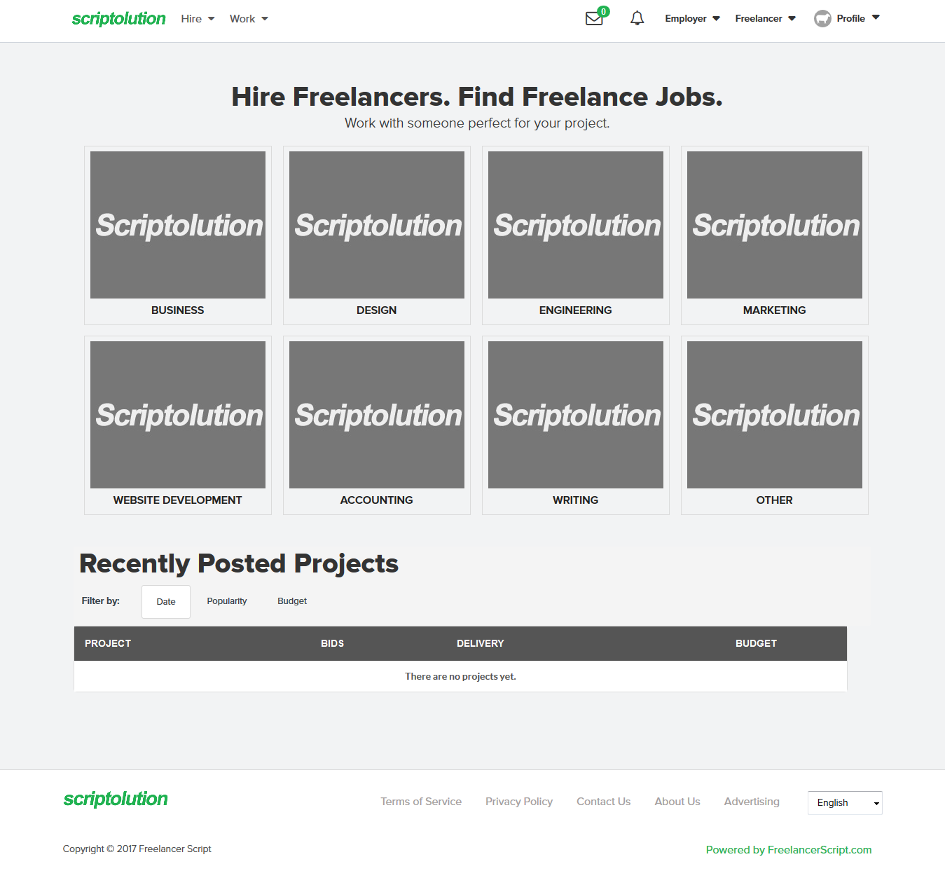

- Hire > Post A Project
* Every user (Work/Hire) Can Post A Project for Hire a worker.
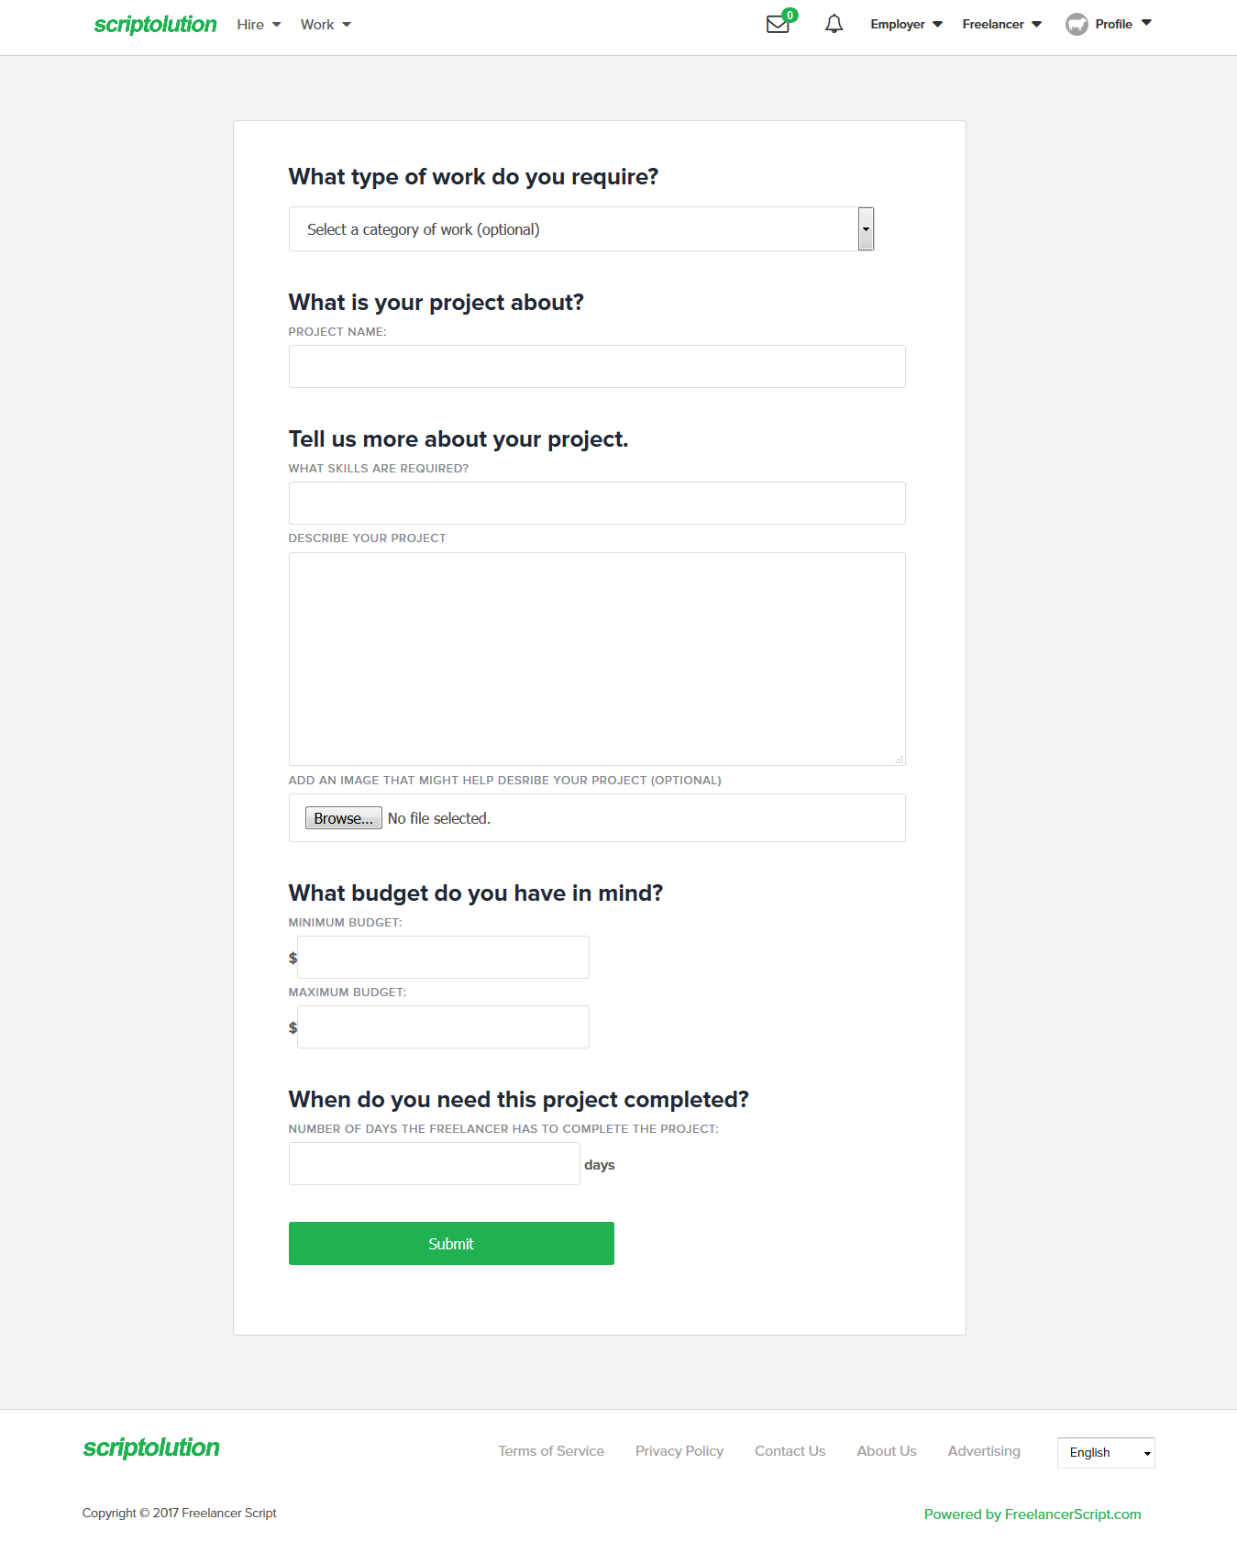
- Hire > Browse Freelancers
* User can Browse Freelancers, and can Contact with them (Not tested, required mail verification but not getting any email for verify). Can Filter user
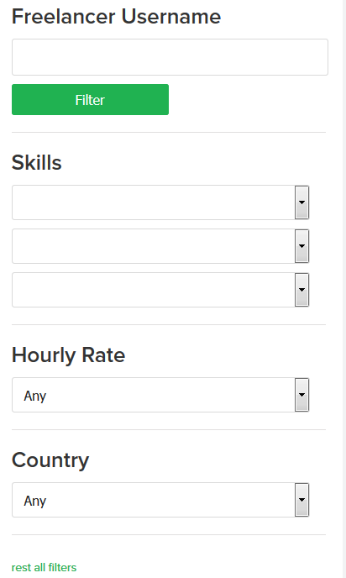

- Work > Browse Projects
User can Browse all project and filter them
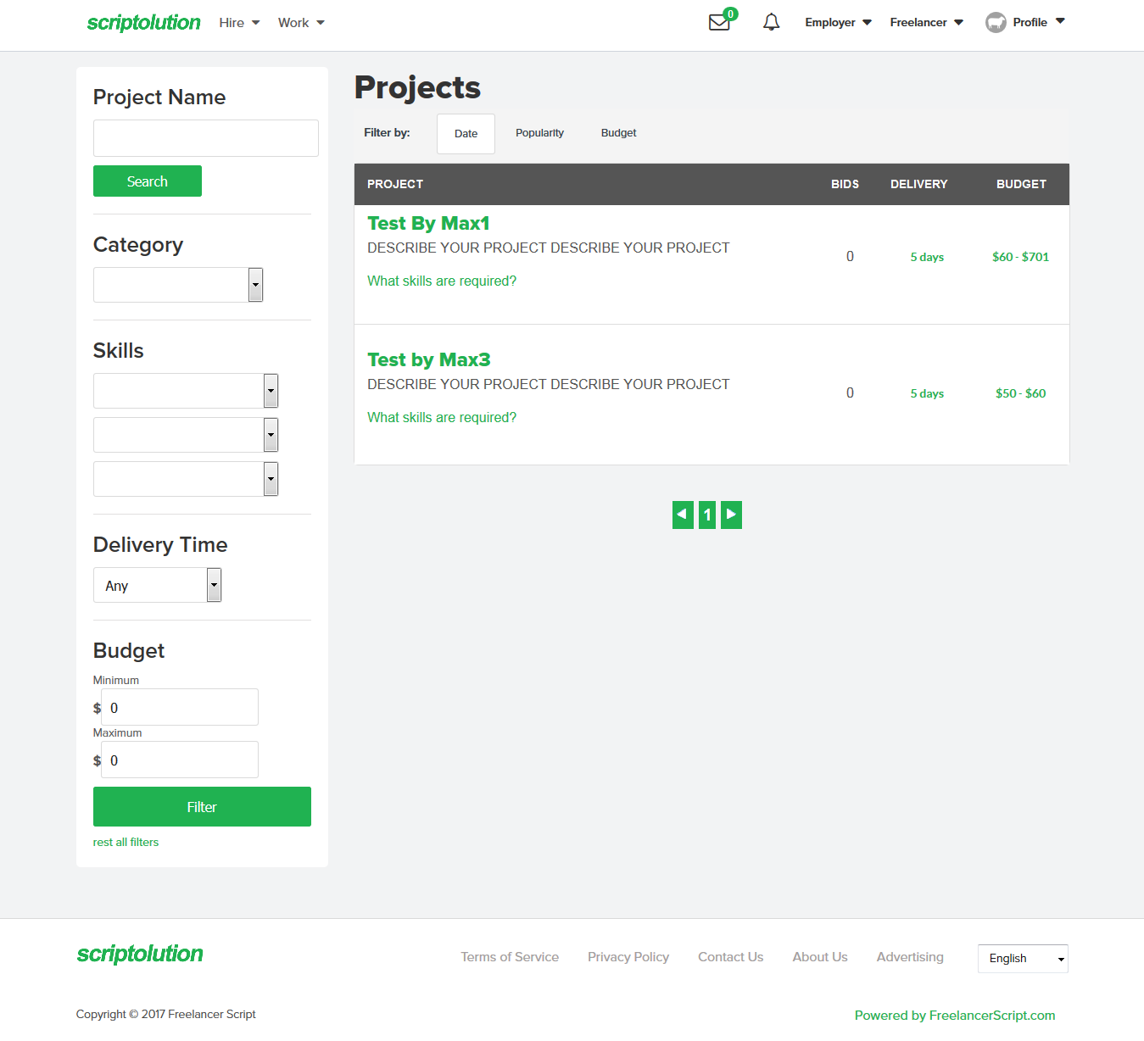
*Any User can Bid on any project if minimum 1 skill match.

- Work > Browse Categories
* User can browse categories then choose any category for browse projects

- Work > Browse Categories
* User can Read his massage. (Maybe can replay, Not tested, required mail verification but not getting any email for verify)

- Employer > Post a Project
* Same as Hire Post a Project.

- Employer > Open Project
* User can manage his own posted Project.
* User can view Proposals
* User can hire worker from Proposals, Have to pay the payment for hire.

- Employer > Awarded Projects
* User can see Awarded Projects information there.

- Employer > Payments
* User can check his balance, Expanse etc

- Freelancer > My Bids
* User Can see his bit project

- Freelancer > My Work
* User can see his work information, Active project, Delivered, Completed, Cancelled project

- Freelancer > Revenues
* User can see his Revenues there

- Freelancer > Membership Payments

- Profile > Settings
* User can Change/Add Information, Paypal/Payza Account

- Profile > My Skills
* User Can manage his skills

- Profile > Membership
* User can upgrade membership from 4 type membership

- Profile > Logout

