Md. Abdur Rahim
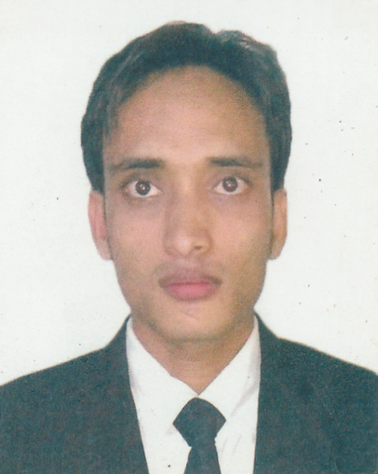

Address:
12/ A Rangking Street, Wari, Dhaka
Cell Number: 01687071066,01716784045
Email: rahimapon009@gmail.com

PERSONAL SUMMERY
A law graduate who is fully aware of the structure, culture and procedures of the legal profession. Experienced in and having a good understanding of how to build relationships with clients and to provide appropriate and effective council and services to them and also able to deliver academic lectures. Easy going by nature and able to liaise with caseofficers, managers and decision makers with regards to on-going legal matters.

OBJECTIVE
To obtain a senior level position & develop a challenging career where I can make a meaningful contribution with deep credence & grow professionally.

ACADEMIC QUALIFICATIONS
Name of the Degree | Subject | Institutions | Year | CGPA |  | Board / University
LL.B.(Honors) | Law | Eastern University  Dhanmoondi, Dhaka | 2016 | 2.73 | N/A
H. S. C | Business Management | Godagari School & College | 2009 | 4.34 | Dhaka
S. S. C | Humanities | Godagari School & College Rajshahi | 2007 | 2.94 | Rajhishahi

Experience

Practicing as Legal Associate
Mojumder Law Associates
From: January 2016 to present

KEY SKILLS AND COMPETENCIES
- Having comprehensive knowledge on Law.
- Having enthusiasm, ambition, self-awareness and initiative.
- Able to work under pressure, priorities, workload and work to deadlines.
- Excellent organizational skills.
- Excellent IT skills including Microsoft Office-Word, Power Point.
- Language efficiency in both English and Bengali.

 | PERSONAL INFORMATION
Father’s Name |  | : | Md. Alfaz Uddin
Mother’s Name |  | : | Shayma Begum.
Present Address |  | : | 12/ A Rangking Street,  Wari, Dhaka .
Permanent Address |  | : | Vill: MaderPur , Post: Mohishal bari,  PS:Godagari Dist: Rajshahi.
Date of Birth |  | : | 31/12/1991
Religion |  | : | Islam
Nationality |  | : | Bangladeshi
National ID No |  | : | 19918123403000063
Marital Status |  | : | Unmarried

REFERENCEs

Advocate Abdur Rub.
Dhaka Judge Court.

DECLARATION

The statements made hereinabove are true to the best of my knowledge and belief and I subscribed my name and signature with this solemn affirmation.

__________________

Md. Abdur Rahim

