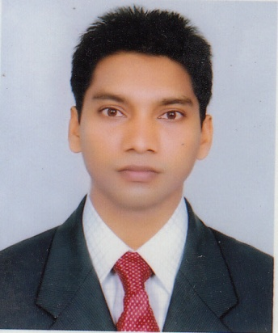
Resume
Of
Md. Elius Kanchon

145,Saleh Sadan (4^{th floor)} )
Motijheel, Dhaka -1000.
Cell: 01717923242,01818725696
E-mail: md.eliuskanchon@yahoo.com

Carrier objectives:
To develop myself as an honest, had working and devoted personnel where I can contribute my experience and Knowledge for the improvement of the organization form which I can development my Professional Skill, Knowledge and find growth Path of Professional career.
Working Experience:
- Worked in Protective Islami Life Insurance Limited. as a Junior Executive Officer, (ICT) Department, from 24 August, 2014 to Still now.
- Worked in Meghna Islami Maltiparpas Co-Operative Ltd. as a Officer (great -1) from 01 Jun 2007 to 01 July 2009.

EDUCATIONAL QUALIFICATION:
M.S.S (Hon’s) in Social Work:
Subject : Social work.
Result : 2nd Class..
Year of exam : 2012.
Institution : Govt. B.M College, Barisal.
University : National University

B.S.S (Hon’s) in Social Work:
Subject : Social work.
Result : 2nd Class.
Year of exam : 2011.
Institution : Govt. B.M College, Barisal.
University : National University.

H.S.C (Business Management):
Specialization : Computer Operation.
Result : 3.74
Year of exam : 2007.
Institution : Islamia College, Barisal.
Board : Technical Board, Dhaka.

S.S.C (Science):
Group : Science
Result : 2.88.
Year : 2003.
Institution : Bogra Cantonment Board High School, Bogra.
Board : Rajshahi.

.
Computer Skill:
Completed the computer Application Course
- MS-Word,
- MS-Excel,
- MS-Access,
- MS-Power point &
- Visual Basic)
- Browsing Of Internet & E-mail.

Personal information:
Full Name : Md. Elius Kanchon.
Father's Name : Md. Rafiqul Islam.
Mother's Name : Farida Begum.
Date of Birth : 15 November 1985 .
Birth Place : Barisal.
Gender : Male.
Marital Status : Single.
Health : Sound.
Height : 5’-6”.
Nationality : Bangladeshi (by birth).
Religion : Islam (Sunni).
Blood Group : AB(+).
Contract Number : 01717923242,01980414180.
National ID No : 19850615143000016.
Permanent Address : Vill: Charkawya Nayane. Post: Charkawya.
Upazilla: Barisal Sadar, Dist: Barisal.
Language Proficience:

- Bengali : Excellent, as mother language.
- English : Smart, as medium of education and over all communication.

I, hereby declared that above mentioned all information are true as my known.

Signature

(Md. Elius Kanchon) Date……………………….

