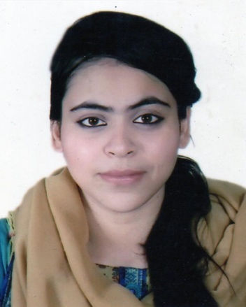
CURRICULUM VITAE
OF

NUSRAT FATHEMA CHOWDHURY
Nurani 11/2 A, Shubidbazar, Sylhet-3100
Cell: +88 01868-484-659
E-mail: nusrat.fathema4@gmail.com

Career Objective

To work in a dynamic professional environment in Staff India, utilizing my creativity and innovative thinking to meet company targets while working on professional development through the experience.

Education

Masters of Business Administration (MBA) 2017-Present
Metropolitan University, Sylhet
Final semester
Current CGPA: 3.50
Key Courses:

- Project Management
- Operation Research
- Strategic Management
- Strategic Management Accounting

Bachelor of Business Administration (BBA) 2017
Leading University, Sylhet
Major: Human Resource Management (HRM)
CGPA: 2.83
Key Courses:

- Financial Accounting
- International Human Resource Management
- Cost and Management Accounting
- Intermediate Accounting
- Introduction to Finance

Higher Secondary School Certificate (HSC) 2013
Scholarshome, Sylhet
GPA: 4.90 Out of 5
Business Studies Group.
Sylhet Board

Secondary School Certificate (SSC) 2011
Blue Bird School & College, Sylhet
GPA: 4.63 Out of 5
Business Studies group
Sylhet Board

Professional Experience

Internship at United Commercial Bank Limited 2017
Amborkhana Branch,
Sylhet

Skills

Proficient in
- MS office,
- MS Word
- MS Power Point
- Internet Browsing
- Primary and Secondary research

Language Proficiency

- Fluent in oral and written English
- Fluent in Bangla

Extra Curricular Activities

- Volunteer in Universal Children’s Day as a member of Volunteer for Bangladesh.
- Female Organizer of Leading University Banned Community.
- Deputy Director of Cultural Affairs of Leading University Model United Nation, Sylhet

Hobby

- Drawing, Listening to Music, Traveling, Designing.

Self Assessment

- Energetic and able to work in a team oriented, multicultural environment
- Aspiration to build a career showing superior performance
- Energetic, Sincere, Hardworking, Honest and Dutiful.
- Able to work at any time at any place

Personal Details

Full Name : Nusrat Fathema Chowdhury
Father’s Name : Md. Khalilur Rahman Chowdhury
Mother’s Name : Shaheen Akther Chowdhury
Date of Birth : 24-11-1994
Nationality : Bangladeshi (By Birth)
Gender : Female
Religion : Islam
Marital Status : Single
Permanent Address : Nurani 11/2 A, Shubidbazar,Sylhet-3100
Present Address : As Above

References

Mamun Kibria Sumon  Proprietor ,  M/s. Kibria Steel Corporation.  Subid Bazar, Sylhet  Cell Phone: +88-01711-335812  E-mail: mamunkibria@yahoo.com | Mohammad Awal Hossen  Senior Lecturer  Department of Business Administration  Leading University, Sylhet  Mob: 01670-727194  E-mail:ahossen178@gmail.com

Declaration:
I hereby state that all the information given in this CV is true to my knowledge.

…………………………………
(Nusrat Fathema Chowdhury)

Date: 21/04/2018

