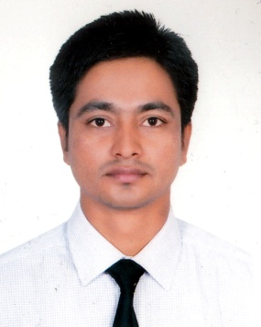
Resume of

MD. AMINUR RAHMAN
Address: Eden 5/2, Road-3, Kallyanpur, Dhaka-1207
Mobile No: 01737-726173
E-mail: neloyrahman1992@gmail.com

Career Objective:
To work in environment where there is an opportunity of self-assessment and self-improvement in both individual and group based work that will ultimately lead to further development.

Career Summary:
I, the undersigned, certify that to the best of my knowledge and belief, these data and information mentioned above are true and correct, which describe my qualifications, my experience, my performance and me.

Experience:
Assistant Engineer
Nassa Group, Nassa Complx (NassaKnit LTD.)
132/1, North Begunbari, Tejgaon I/A, Dhaka – 1208
January, 2017 Runing Now

Sub-Assistant Engineer
Dutch Bangla Bank Limited
House No-47, Road No-9/A, Satmojid Road,
Dhanmondi R/A, Dhaka-1209
June, 2014 – December 2016

Junior Instructor, Electrical,
Uttorbongo Polytechnic Institute, Naogoan.
November, 2012 - December, 2013.

Training:
132/133KV Grid Sub-Station
Power Grid Company of Bangladesh limited.
Khatakhali, Rajshahi.

Project:
Automatic Solar panel tracker
Daffodil Inernational University
Dhanmondi-32, Dhaka

Academic Qualification:

BSc in engineering
Institute: Daffodil International University
Department: Electrical & Electronic Engineering
Result: CGPA-3.42 out of 4
Passing Year: 2017

Diploma in Engineering
Institute: Rajshahi Polytechnic Institute
Department: Electrical Technology
Result: CGPA-3.33 out of 4
Passing Year: 2012

SSC
Institute: Beritola Academy
Department: Science
Result: CGPA-5 out of 5
Passing Year: 2008

Computer skill:
Institute: Bangladesh Technical Education Board, Dhaka
Department: Computer Diploma Database Programming
Result: A+

Language skill:
Bangla: Speaking, Writing & Listening high proficiency.
English: Speaking, Writing & Listening medium proficiency.

Extra Activities:
- Basic Adobe Photoshop, Windows Xp, Internet browsing
- Joint in different club, Rover Squatting
- Playing different indoor & outdoor games

Personal Attributes:
- Self confident & being positive
- Ability to manage time & being flexible
- Ability to work efficiently under pressure & fulfill deadline
- Open minded in adapting challenging situation
- Always ready to learn new technology

Personal Details:
Father's Name : Md. Abdus Salam
Mother's Name : Rahena Begum
Date of Birth : September 25, 1992
Gender : Male
Marital Status : Single
Nationality : Bangladeshi
National Id No : 19926412877000020
Religion : Islam
Permanent Address : Village- Udaysree, Post- Khelna, Thana- Dhamoirhat, District- Naogaon.
Current Location : Dhaka

Reference (s):

Md.Dara Abdus Satter  Assistant Professor & Associate Head  Department of EEE  Daffodil International University  Phone: +8801716-795779  Email: abdussatter@daffodilvarsity.edu.bd | Md. Mooradujjaman-zaman  Technical Supervisor  Adabor division, Dhaka power  Distribution company.  Phone: +8801719-452688

MD. AMINUR RAHMAN

