RESUME OF
ANAMIKA DATTA

Address: | 53/1, Tantipara, Sylhet
Mobile: | 01743424449
E-mail: | anamikatumpa55@gmail.com

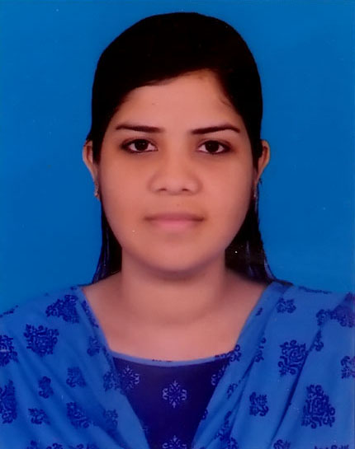

Career objective:
Seeking for a position to any organization where I can enhance my practical knowledge and skills congregated from my theoretical learning by giving my best to the organization.

experience:
I have three (03) months working experience as an intern at City Bank Ltd. Bandar Bazar branch, Sylhet. I worked here as a service ambassador and also assist officers and executives of their daily work which includes-
- Dealing with customers
- Filling account form
- Card issuing
- Cheque instrument issuing
- Voucher checking
- Document analysis

Academic Qualification:
Exam Title | Major | Institute | CGPA/GPA | Pass Year
Master’s in Business Administration | Marketing | Leading University, Sylhet | 3.94 (4th Semester) | On Progress
Bachelor of Business Administration | Marketing | Leading University, Sylhet | 3.71 | 2016
H.S.C. | Business Studies | The Buds Residential Model School & College | 5.00 | 2012
S.S.C. | Science | The Buds Residential Model School & College | 5.00 | 2010

Personal DETAILS:
Father's Name | Debesh Ranjan Datta
Mother's Name | Anjana Datta
Date of Birth | 30th November 1993
Religion | Hinduism
National ID | 19935818385000119
Marital Status | Single
Blood Group | O+ (Positive)
Nationality | Bangladeshi
Permanent Address | Village- Sobujbag R/A, P.O-Sreemangal, P.S-Sreemangal, District-Moulvibazar.

KEY SKILLS AND COMPETENCIES:
Personal Skills | - Self-motive and hard worker with an ability to perform under pressure.  - Always eager to adopt new technologies.  - Quick learner and result oriented.
Computer Skills | Operating System |  | Windows XP, Windows 7, Windows 8 and Windows 10.
Computer Skills | Applications |  | E-mail/Browsing.
Computer Skills | Office Applications |  | Microsoft Word, Microsoft Excel, Microsoft Power Point, Microsoft Access.
Language Proficiency | Language | Reading |  | Writing | Speaking
Language Proficiency | English | High |  | High | Medium
Language Proficiency | Bengali | High |  | High | High
Hobbies | Interested in Playing music, reading books, traveling, internet browsing, and doing something innovative.

Reference (s):

Name : Debashish Syam  Organization: City Bank Limited  Designation: Assistant Vice President & Senior Manager  Mobile: +8801715777808  E-Mail: debashish.syam@thecitybank.com | Name : Shamsu Uddin Shakib  Organization: Leading University  Designation: Assistant Professor  Mobile: +8801717502120  E-Mail: sushakib@yahoo.com

declaration:
Hereby, I solemnly declare that all the above information is correct to the best of my knowledge and belief.

………………….
(Anamika Datta)

