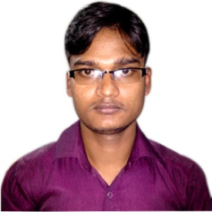
Resume of
Md. Al-Amin-Arafat
Mobil: 01722613688
Mail Address: Village: Sit Sarai Menazerpul
Post: Haragach, Upzilla : Kaunia, District : Rangpur.
CAREER OBJECTIVE
Looking Forward To Build My Career in a Dynamic And Progressive Organization, where I
can prove my talents and skills and to contribute in the welfare and development for the
organization as well as myself.
ACADEMIC QUALIFICATION
European University Of Bangladesh : Certificate (BSC & CSE)
Board : Dhaka
Group : Computer Since Engineer
GPA : Appade
Year : 2018
Baily Braze Agriculture & Polytechnic Institute: Certificate (Diploma)
Board : Dhaka
Group : Computer
GPA : 2.87 out of 4.00
Year : 2015
Haragach M/L High School: secondary School Certificate (S.S.C)
Board : Rajshahi
Group : Science
GPS : 3.44 out of 5.00
Year : 2008
PROFESSIONAL EXPERIENCE
Organization Name : Basic Thread Industry Limited.
Post Name : customer care executive.
Responsibilities : customer care.
Start Date : 17- November-2014.
End Date : Till Now.
LANGUAGE SKILL
Fluent in writing speaking listening in bangle and English as the second language.
Computer Skill.
1. Multimedia (Video Editing, Audio Editing)
2. Office (Excel, Power Point, MS Word)
3. Graphic (Adobe Photoshop,)
4. Network. (Internet Browsing, Mail Checking /Outlook/Gmail/Yahoo, Computer Servicing )
5. Computer Assembly.
6. Networking.
PERSONAL INTEREST
Watching Cricket Match, Traveling, reading, computer servicing, newspaper reading book, magazines, listening music and surfing internet.
PERSONAL INFORMATION
Father’s Name : Md. Abul Kashem
Mother Name : Most. Rashna Begum
Nationality : Bangladeshi (by birth)
Marital Status : Unmarried
Religion : Islam
Date of Birth : 30th November, 1992
Blood Group : o (+)ve
PERMANENT ADDRESS
Village : Sit Sarai Menazerpul
Post : Haragach
Upzilla : Kaunia
District : Rangpur
Signature
……………………………….
Md. Al-Amin-Arafat

