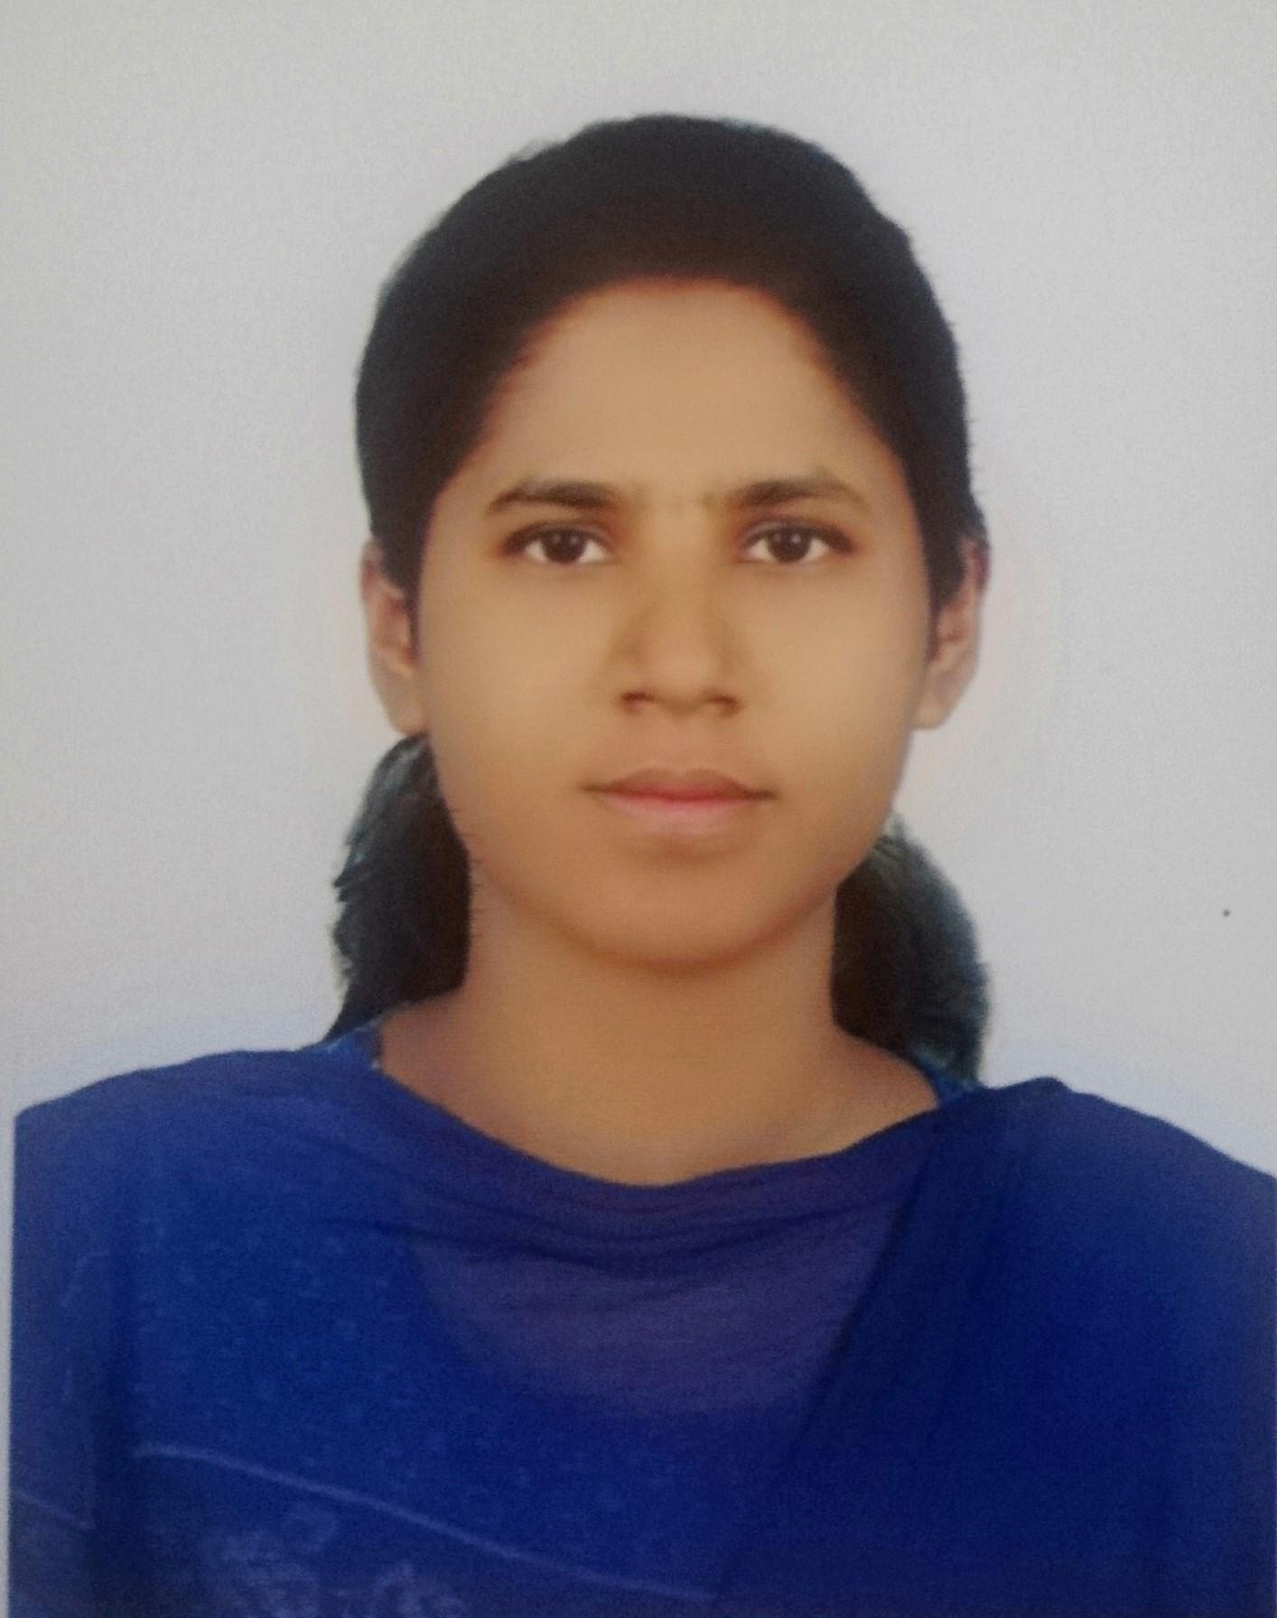
Jannatul Tajrin Shammi
Address: House#180/F/6/1/D
Titas Road, East Rampura, Dhaka- 1219
Contact No: 01755997258
E-mail: jannatultajrin33@gmail.com

Career Objective

To succeed in an environment of growth and excellence and earn a job which provides me job satisfaction and self-development and help me to achieve personal as well as organizational goals.

Academic Records

BRAC University
B.Sc in Computer Science and Engineering (CSE) - 2018
CGPA: 3.14 out of 4

Ideal School and College
Higher Secondary Certificate(HSC) - 2013
GPA: 4.60 out of 5

Ideal School and College
Secondary School Certificate (SSC) - 2011
GPA: 5.00 out of 5.00

Work Experience

Blackbird.oi, USA
Research Programmer
January 2019- April 2019(remote job)
Responsibilities:
- compare Algorithms to find better solutions for forgery image detection
- convert Matlab code into python
- image processing for forgery detection

Training

- Participated in Top-up IT training conducted by Ernst & Young LLP, India under LICT project of Bangladesh Computer Council (BCC), ICT Division on JAVA under NASSCOM IT-ITES Sector skill Council (SSC) (2017-2018)
- Participated in Workshop on Big Data and Machine Learning; Organized by BRAC University Computer Club, Dhaka, September 25, 2017
- Participated in Workshop on Machine Learning and Machine Vision; Organized by CVIS Research Lab, BRAC University, Dhaka, July 9-July20, 2018.
- Complete Python Essential Training from LinkedIn Learning (online learning platform)
- Participated in CGPA VS Extracurricular Activities-The Reality in Bangladesh Job Market” organized by IABC BRAC University, Dhaka.
- Certificate of Attendance for completing Mindfulness Stress Reduction as an activity in the Residential Semester

Thesis and Projects

Detection and Recognition of Fishes using SURF and CNN
Thesis: Detection and Recognition of Bangladeshi Fishes Using SURF and convolutional neural network
Technologies used: MATLAB, image processing, machine learning, Neural Network

Building software to detect over speeding cars and giving alert
Technologies used: Andriod, Arduino

IoT based real-time noise mapping system for urban sound pollution study
Technologies used: Arduino, Grove sound sensor, javascript

Restaurant Management
Design a website for a restaurant while the customer can see the menu, price, and available offers, etc.
Technologies used: PHP,CSS,HTML,MySQL

Web Development
Travel Agency Management System where users can see available offers and book advance.
Technologies used: HTML, CSS, JavaScript,PHP,MYSQL

Fraud email detection using a decision tree algorithm.
Technologies used: Python, Pandas, numpy

Extra-Curricular Activities

- Director of Human Resource Department Brac University Art Society.
- Coordinator at BRAC University Adventure club
(Organized tours in Bandarban. Sylhet and other short tours )
- General member of BRAC University Computer Club
- Several prizes in Book reading competitions like from Bishosahitto Kendra etc

Skills

Technologies: Java, Python, HTML, CSS, JavaScript, Bootstrap, MS Excel, MS word
Language Skill: Good communication skill in both Bangla and English

Publications

- M. I. Pavel, I. Chowdhury, A. Akther, Adiba Shuhin, J. Tajrin, “Detection and Recognition of Bangladeshi Fishes Using SURF and convolutional neural network”, International Journal of Advanced Research.
- Md. Mehedi Rahman, Jannatul Tajrin, Abul Hasnat, Naushad Uzzaman and G. M. Atiqur Rahaman, SMIFD: Novel Social Media Image Forgery Detection Database. (ICCIT 2019, Accepted)

Reference (s)
DR. JIA UDDIN
Associate Professor
Computer Science and Engineering
BRAC University
Email: jia.uddin@bracu.ac.bd

