CURRICULUM VITAE
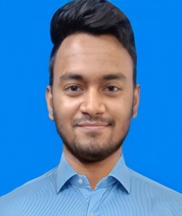
OF
Call+01639097871,01888738172
E-mail-zabedhossain290@gmail.com

CAREER OBJECTIVE:

I would like to work in an organization where I can demonstrate my knowledge and skill to Proof myself to be a quick learner. I would like the job with great sense of responsibilities ,Enjoy the challenge of new situation and expect to make positive contribution from my position.

PERSONAL DETAILS :
Name : Jabed Hossain
Father’s name : MD. Yousuf
Mother’s nsme : Rasheda Akter
Date of Birth : 15th June, 2000
Gender : male
Marital Status : Unmarried
Nationality : Bangladeshi
Religion : Islam
Parmanent Address :House. Raja bari,Village: East Bijoy Sing,
Post : Feni, Dis : Feni.
Present Address : House. Raja bari,Village: East Bijoy Sing,
Post : Feni, Dis : Feni.

Educational Qualification:

Class | Institute | Group | Passing Year | Result
SSC | Alhaz Kobbad Ahammad Model High School | Science | 2017 | 4.09(out of 5.00)
Diploma | Institute of Computer Science & Technology (ICST) | Civil | 2022 | 3.70(out of 4.00)

Computer Skills: a) Auto CAD-2D,3D,Studio Max,Microsoft Excel,Microsoft Word.
Certification : I, the undersigned certify that to the best of my knowledge & believer this
Curriculam Vitae correctly describes myself,my alification&my experience.
Experience Received:
a) Consultant Engineer, Office & Site Engineer, Estimated. (Dec,2021-Continuing)
Dream Palace Design &Developers Office ,Upazila Gate Chauddagram, Cumilla
Language Skills:
Have a good skill on both Bengali&English(Reading&Writing)
Training:
Internship:(18 December,2021 to 12 March,2022) Dream Palace design&Developers,Chouddagram.

I am undersingned, hereby declare that I will be responsible for any wrong information provided here.

Date: Signature

