CURRICULUM VITAE
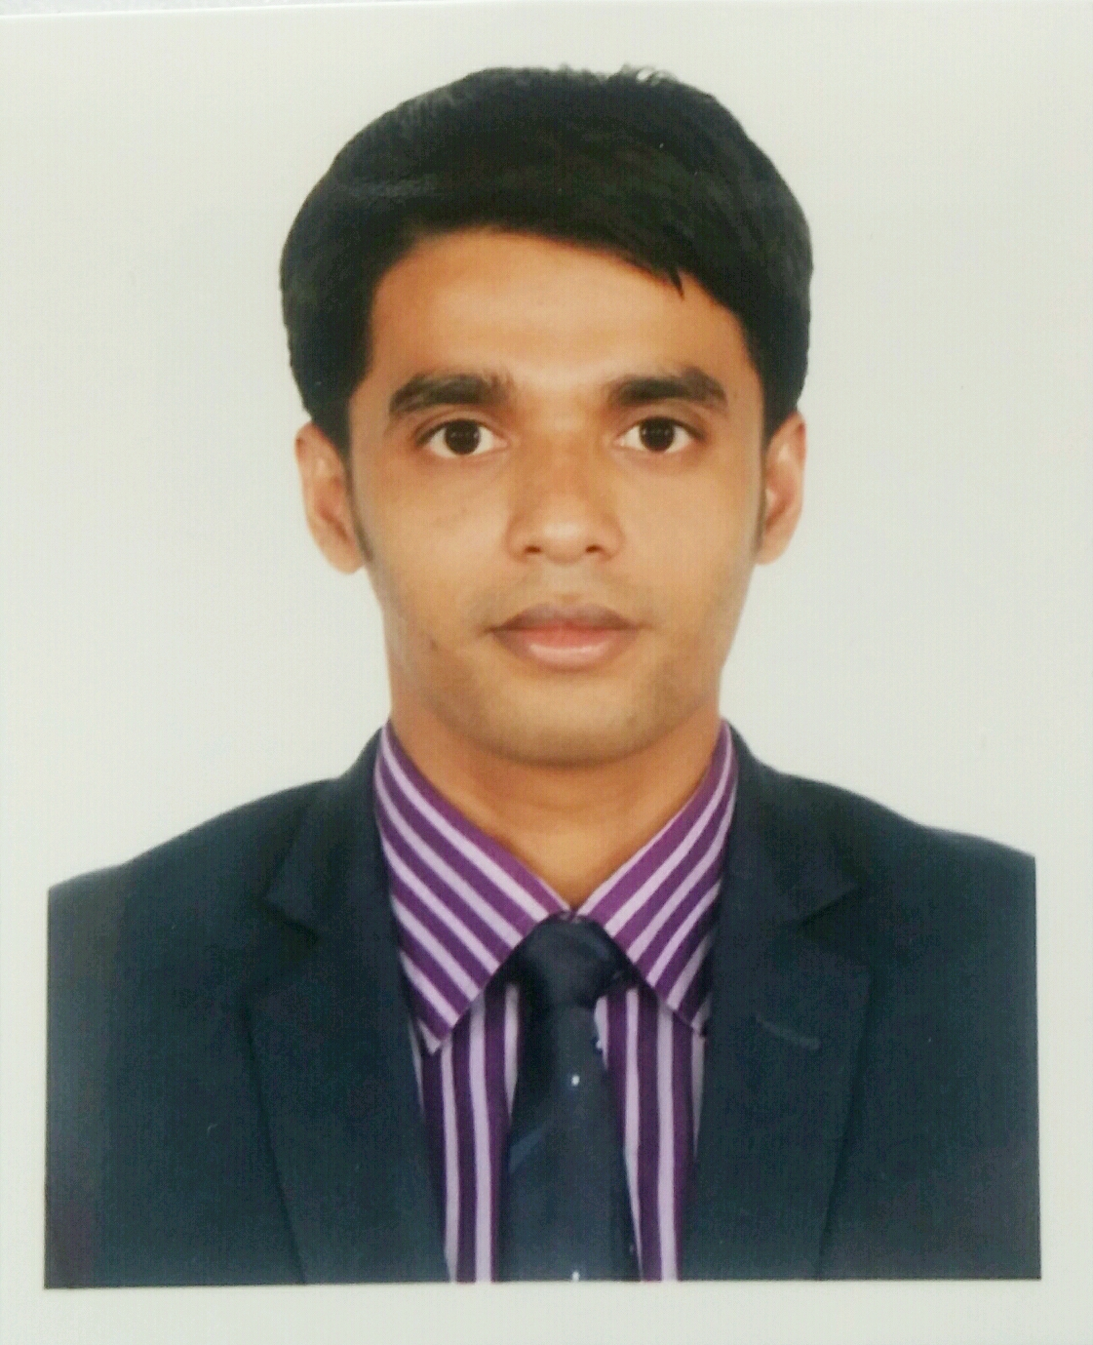

Moinul Islam
Mailing Address : 457/1 Ashkuna, Medical Road, Dakkinkhan, Dhaka.
Cell: +88001717569844
E-mail: moinpul@gmail.com

Career Objective
Intend to work in challenging and competitive environment where the strong sense of responsibility and commitment to learn & grow are valued. I would like to establish myself as a successful professional with full dedication to the organization.

Educational Pursuits

B.B.A Sylhet International University, Sylhet
2012-2016, Department of Business Administration,
Major in Finance & Banking
CGPA- 3.34 on 4-point scale.

H.S.C Madan Mohan College, Sylhet
2011, Business Studies, Sylhet Board
GPA- 3.90 on 5-point scale.

S.S.C Dungria High School
2009, Science, Sylhet Board
GPA- 4.06 on 5-point scale.

Professional Qualification

- Certificate Course in Computer Application.
Course Name : Diploma in Computer Science & Engineering
Course Duration : 6 months.
Name of Institution : National Youth Development and Training Center (NYDTC)

Training Summary
- Working In Skills for employment investment program(SEIP) as a trainee in Impel Service & Solutions(ISSL) in Mastering Customer Service(Level 1)
- Trainee in Speaking fluency for BACCO Call Centre Operatives under the SEIP program From British Council.
- Internship in Southeast Bank Limited (3 months)
Personal Interest
- Listening Music, Watching Movies & Travelling

Computer Skills

Operating System: Windows (98, 2000, XP, 7, 8, 10)
Application Software: Microsoft Office (Word, Excel, Power Point) and Others.

general competency and ability

      - Proficiency in speaking and writing both English and Bengali languages.
      - Good inter personal, communication and presentation skills.
- Capability of working as a team member and influence others.

Personal Details

Name : Moinul Islam
Father’s Name : Md. Amir Uddin
Mother’s Name : Jahanara Begum
Permanent Address : Mohona-23, Block-D, kucherpara, Pathantula, Sylhet.
Present Address : 457/1 Ashkuna, Medical Road, Dakkinkhan, Dhaka.
Date of Birth : 5th November, 1993.
National ID : 19939196208000191
Blood Group : O+
Contact number : +88001717-569844
Weight : 52 kg
Religion : Islam
Nationality : Bangladeshi (By Birth)
References:
Md. Gousul Alam
Executive Officer
Prime Bank Limited
Head Office
Motijheel, Dhaka
Cell: 01749644796
Email: gousul_sust@yahoo.com

Mr. Amjad Hussain
Senior Vice President
Southeast Bank Limited
Pathantula Branch
Phone: 0821-724545, 0821-72430
Email: amjad.hussain@southeastbank.com.bd

I do hereby ensure that the all information above is authentic.



......................................
(Moinul Islam)

