
RESUME OF
MD. GOLAM MOHIUDDIN (HIMEL)
Cell: 01749-119090
Facebook: https://www.facebook.com/GmMohiuddinHimel
E-mail: gm.mohiuddin.555@gmail.com

Objectives:

Work History:

Academic Qualification:

Career Objective

To work in a challenging environment, achieve skills in the respective field & work for the simultaneous progression of organization and myself.
Work Experience:

Last Job Details:
Company Name  Designation  Department  Duration | :  :  :  : | FARR Ceramics LTD (Manufacturing Plant)  Planning & IT Officer  Planning, MIS & IT  02 November 2015 To Till Now

Last Job Responsibilities:
- Performed general office duties and administrative task.
- Prepare daily production plans and plans that are presented at the production meeting.
- Prepared & submitting: Daily production status,
Daily production achievement,
Daily productivity report,
- To verify delivery schedule and prepared stock reports and daily delivery reports.
- Working in hardware and internal networking.

Previous Job Details:
Company name  Designation  Admin  Duration | :  :  :  : | Unique Vocational Training center (UVTC).  Asst. Admin Officer.  Admin.  03 August 2014 to 30 July 2015.

Previous Job Responsibilities:

- Performed general office duties and administrative task.
- Prepare and submit daily and monthly office attendance and leave reports. Store inventory & gate pass maintenance.
Details Academic Background

BSC in Engineering
Name of the University : Asian University of Bangladesh (AUB)
Department : BSC in CSE
Result : Not-published

Diploma in Engineering
Name of the Institution : Faridpur Polytechnic Institute
Group : Computer Science (CS)
Examination Year : 2014
Result : Second Division
Board : BTEB

Secondary School Certificate (SSC)
Name of the Examination : SSC
Group : Science
Examination Year : 2009
Result : 4.19
Board : Dhaka
Personal Information:

Address:

Training & Skill:

Activities:

Reference:

Signature:
Personal Information
Certificate Name  Father’s Name  Mother’s Name  Date of birth  Gender  Height  Wight  Marital Status  Religion  Nationality  NID Number | :  :  :  :  :  :  :  :  :  :  : | Golam Mohiuddin  MD. Younus Ali  Mrs. Shayera Khandoker  05 August,1994  Male  5’7”  65 Kg  Unmarried  Islam  Bangladeshi (By birth)  19942914713000258

Permanent Address | Present Address
Village: Bilmamud pur  Post Office: Baitul aman  Police Station: Faridpur sadar  District: Faridpur  Country: Bangladesh. | Village: Noula para  Post Office: Bhabanipur  Police Station: Gazipur sadar  District: Gazupur  Country: Bangladesh.

Skill & Knowledge

Computer Skill: Microsoft Office, Hardware & Networking, Database, Adobe Photoshop, Adobe illustrator.

Communication Skill: Good command in both written and spoken English, Bengali & Hindi.

Personal Values

- Good communication and interpersonal sensitivity.
- Good in oral and written communication Bengali and English.
- Good interpersonal relationship and possess supervision skill.
- Good oriented and enjoys new challenges.
- Excellent leadership quality with inspiring ability.

Other Activities

- Play Table Tanis, Pool, Badminton, Chess, Cricket, Football, & Handball.
- Many Time Champion of Table Tennis & Badminton Tournament.
- Reading Books, Reading Newspaper, Drawing Picture.

MD. Shamimur Rahman
Planning, MIS, & IT Manager. FARR Ceramics Ltd.
Mobile: 01670-166745

MD. Younus Ali
Four Man (Mechanical Engineer) at cotton Development board, Bangladesh.
Mobile: 01749119090

Certification:
I, the undersigned, hereby, declare that to the best of my knowledge and belief, this resume correctly describes my qualifications, my skills and me & thank you.

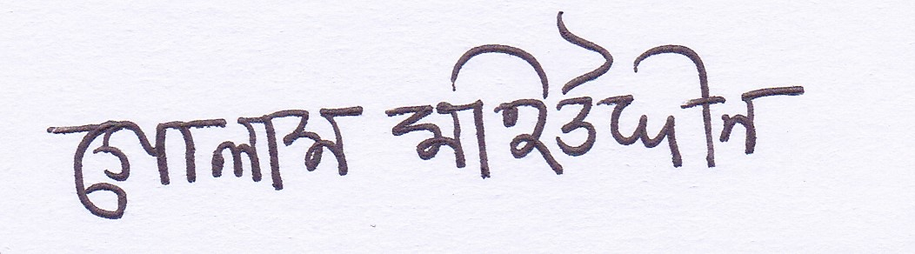

_______________________

Md. Golam Mohiuddin Himel

