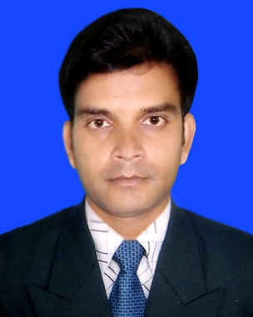

RESUME OF

MD. RANA SARKER
Mailing Address:

Vill: Gazibari, P.O: Naihati Bazar
P.S: Ashulia, Sub-Dist: Savar, Dist: Dhaka.
E-mail: ranasarker1991@gmail.com
Mobile: 01922-541635

Objective

Intend to work hard in a challenging and competitive environment with full dedication for the achievement of organization objectives under satisfying job contact where the dignity of work provides self-satisfaction and provides potential avenues for learning experience.
Attributes
- Proficient in the use of computer.
- Effective in maintaining good communication with others.
- Report and Presentation.
Educational Qualifications
Masters of Arts (M.A. in E.L.T) |  | 2018
University  Subject | : Jahangirnagar University  : Major in English
Result (CGPA) | : 3.12 out of 4.00
Bachelor of Arts (B.A. in English) |  | 2010
University | : City University of Bangladesh.
Subject | : Major in English
Result(CGPA) | : 3.56 out of 4.00
Higher Secondary Certificate (H.S.C) |  | 2011
Institution Name | : Dhamrai Govt. College.
Board | : Dhaka
Group | : Science
Result(GPA) | : 2.90 out of 5.00

Secondary School Certificate (S.S.C) |  | 2007
Institution name | : Baidgoan High School.
Board | : Dhaka
Group | : Science
Result(GPA) | : 3.56 out of 5.00

Languages Have fluent ability to speak & write both in English & Bengali.
Personal Details
Father’s name | Md. Labib Uddin Sarker
Mother’s name | Firoza Begum
Permanent Address | Vill- Gazibari, P.O- Naihati Bazar , P.S- Ashulia, Sub-Dist: Savar,  Dist.: Dhaka.
Date of birth | 12-07-1992
Nationality | Bangladeshi (by born)
Religion: | Islam
Marital Status | Married
Gender | Male
NID No. | 7317386311
Blood Group | B (+ve)
Computer Literacy

Basic Computer Operating and Software Packages Course -6 months
(National Youth Training Center)
      - Operating System:Windows XP, 7, 8, 10.
      - Internet Browsing.
      - Microsoft Office, Excel, Power Point, Photoshop.
      - Bangla and English both typing speed 20 up.
Self-Appraisal

The followings are true for me –
- I am pious and assiduous. By the grace of God/Allah the Almighty, I can learn anything very quickly.
- I like challenges and I enjoy challenges. Usually, I don’t like to slack in doing my duties.
- I am punctual and truthful.
Extra Curricular Activities Knowledge about Labor Law and Income Tax.
Reference

Name: Dr. Dewankhairul Alam
Designation: MBBS, Bcs(Health),PGT (Madicine& Cardiology) RMO
Institution: Bangladesh Korea Friendship Hospital, Zirani, Savar, Dhaka.
Cell Phone: 01932-727396.

Signature
Date:

