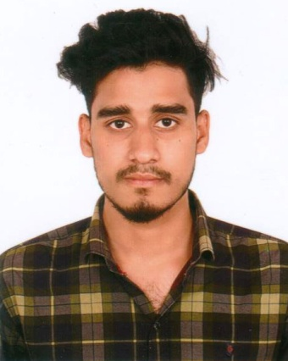
CURRICULUM VITAE
Md. Razib Hossain

Contact
- 01872-946557
- smhridoyahmed13@gmail.com

Career Objective
To be an astute learner in an esteemed organization to start off my career in order to succeed in an environment of growth and excellence and earn a job which provides me satisfaction and self-development and help me to achieve organizational goal.

Education Qualification
Marine Diploma
Institute : Institute of Marine Technology, Sirajganj
Group : Marine
Passing year : 5th Semester Running

Marine Trade
Institute : Bangladesh Institute of Marine Technology
Subject : Marine
Result : 3.07 out of 4.00
Passing Year : 2018

Secondary School Certificate (SSC)
Institute : Vibekananda High School
Group : Science
GPA : 5.00 out of 5.00
Passing year : 2016
Board : Dhaka

Strengths
- Ability to work independently and with group.
- Capability of organizing and leading a group.
- Capability of communicating with people effectively.
- Quick learning ability and strong interpersonal skill.
- Highly self-motivated, enthusiastic and dedicated to work.

Personal details
Fathers name : Md. Jamsher Ali
Mothers name : Rina Begum
Permanent address : Vill- Shar Polshia,
Post- Nikrail
P.S- Bhuapur
Dist- Tangail

Mailing address: 61/A, West Rajabazar
Sher-E-Bangla Nagar
Dhaka-1215.
Date of birth : 12 February, 2000
Religion : Islam
Blood group : A+ (positive)
Nationality : Bangladeshi
NID No : 511 439 5550
Marital Status : Single
Height : 5`-7``

Experience:

- Company Name : Bangladesh Navy Dockyard
Designation : Ship Engine Maintenance
Duration : 6 Months

Professional Training/ Development program
- Institute : Bangladesh Navy Dockyard
Course Topic : Marine
Duration : 6 Months

Skills
Communication Skill:
Language
Bengali
Proficiency Level: Native
Skill: Reading, Writing, Speaking.

English
Proficiency Level: Moderate
Skill: Reading, Writing, Speaking

Japanese
Proficiency Level: Medium
Skill: Reading, Writing, Speaking

Microsoft Word:

Microsoft Excel:

Internet Browsing:

Reference-2
Reference-1

Declaration:
I hereby declare that the all information given above is true to the best of my knowledge and belief.


___________________
Md. Razib Hossain

