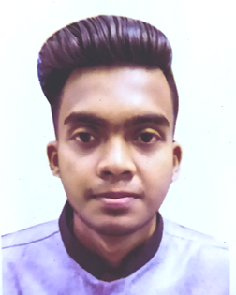
RESUME
OF
I.M. Zia-ul Jahangir
Cell # 01818-542451

House: 260, Road: 06, CDA R/A,
Agrabad, Chattogram-4100.
E-mail: ziauljahangir@gmail.com

Career Objective:

Dream to build my career in a large organization. Thirst to face new challenges & ready to work in a demanding environment under pressure.

Personal Attributes:

- Working sincerely & eager to learn;
- Strong perception;
- Aspiration to build a career showing superior performance;
- Willing to work in a team.

Examination | :Bachelor of Business Administration (BBA)
Institution | :National University (Omer Gani MES College)
Subject/ Department | :Management
Session | :2018-19
Examination | :Higher Secondary Certificate [HSC]
Institution | :Islamia Degree College
Group | :Business Studies
Result | :GPA 2.83
Exam year | :2018
Board | :Chattogram
Examination | :Secondary School Certificate [SSC]
Institution | :Agrabad Govt. Colony High School
Group | :Business Studies
Result | :GPA 4.22
Exam year | :2015
Board | :Chattogram
Educational Background:

Experience:
- I have worked as a Team Member of National Household Database [NHD] 2018.
- Work as an Office Management & Teacher in a Privet Coaching Center from 10th January, 2018 to till now.

Computer Knowledge: MS Office, Internet Browsing, E-mail

Strengths:

- Sharp sense of social responsibility
- Learning mentality
- Strong communication skill

Language Proficiency:

- Fluent in Bengali and English, excellent at written and spoken in English.
Interest & Hobbies:

- Reading Books & Newspaper,
- Listening music,
- Watching movie,
- Traveling,
- Cycling & Biking
- Playing Cricket
- Social work
Father’s Name | :Md Jahangir Alam Bhuiyan
Mother’s Name | :Nilufar Jahangir
Date of Birth | :28th September, 1998
Gender | :Male
Marital Status: | :Unmarried
NID | :7355041349
Height | :5'10"
Nationality | :Bangladeshi by birth
Religion | :Islam
Permanent Address: | :Vill:- Mohalanka, P.O:- Baliadi- 4311,  P.S:- Mirsharai, Chattogram
Personal Information:


_______________
Signature
Date:

