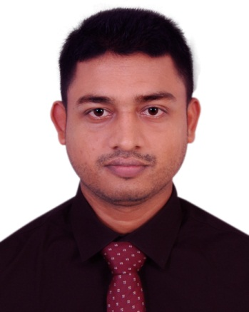
Resume of
Md. Gulam Kibria
Faridpur, Nurpur, Dakshin Surma, Sylhet.
Mobile: +8801710445163
E-mail: mdkibria1993@gmail.com

CAREER OBJECTIVE

Want to be attaching with some creative works. Apply theoretical and practical of my academic knowledge to build up my career with highest sincerity and to concentrate on every step of benefit for the organization.

EDUCATIONAL QUALIFICATION

M.A in English
University : North East University Bangladesh, Telihaor, Sheikghat, Sylhet.
Passing Year : 2018
Result : 3.70 out of 4.00

B.A (Hons.) in English
University : North East University Bangladesh, Telihaor, Sheikghat, Sylhet.
Passing Year : 2017
Result : 3.70 out of 4.00

Higher Secondary Certificate (H.S.C)
Group : Science
Passing Year : 2012
Result : 4.70 Out of 5.00
College : Sylhet Government College.
Board : Sylhet Board.

Secondary School Certificate (S.S.C)
Group : Science
Passing Year : 2010
Result : 5.00 Out of 5.00
School : Sylhet Government Pilot High School
Board : Sylhet Board.

EMPLOYMENT
- I’ve worked as a lecturer of English at Starlight College, Sylhet from November 2017 to April 2018.

COMPUTER LITERACY
- Operating Software, MS word, MS Power point, Internet Browsing, E-mail.

HIGHLIGHTS OF QUALIFICATIONS
- Excellent leadership, management and motivational skills.
- Effective interpersonal & excellent communication skills.
- Strong Self-confidence, flexibility and sense of humor.
- Ability to maintain confidentiality of work related information and materials.
- Strong ability to work effectively with co-workers as a part of team.
- Substantial organizational and problem-solving skills.

FIELDS OF INTEREST
- I enjoy listening to all types of Radio programs especially BBC and watching films. I have a keen interest in reading literature and meet different people.
- Playing football amuse me very much.

COMMUNICATION SKILLS
- English is the second language. Good at communicating with others, and participating in group and individual work.
- Bangla is the mother tongue.

EXTRA-CURRICULAR ACHIEVEMENTS
- President (2016-2017) and Joint Secretary (2015-2016) of NEUB English Council.
- Media-Hype (2015-2016) of NEUB Debating Society.

PERSONAL DETAILS

Certificate Name : Md. Gulam Kibria
Father’s Name : Md. Ataur Rahman
Mother’s Name : Mst. Asia Begum
Permanent Address : Faridpur, Nurpur, Lalabazar, Dakshin Surma, Sylhet
Date of Birth : 14-07-1995
Nationality : Bangladeshi by birth
Religion : Islam
Marital Status : Unmarried
Sex : Male
Blood Group : B+ (Positive)

REFERENCES

- Md. Shamsul Kabir
Assistant Professor & Head
Department of English,
North East University Bangladesh Sylhet.
Mobile: +8801819560206
E-mail: shamu174@hotmail.com

- Muhammad Shuhag Ali
Senior Officer
Islami Bank Bangladesh Limited
Dakshin Surma Branch, Sylhet.
Address: Muhini 52, Lamapara, Shibgonj, Sylhet.
Contact: +8801795673290.
Email: Shuhagaliibbl@gmail.com

I certify that above information’s are correct to the best of my knowledge.
Yours truly

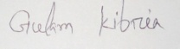

(Md. Gulam Kibria)
Date : 19-09-2018

