CAREER OBJECTIVE | Looking for a challenging job where I will have the scope to intrig my potentiality, Skill to do something creative and I will be able to enhance my knowledge and prosper in my career.
ACADEMIC QUALIFICATION | EXAM TITLE | SUBJECT | INSTITUTE | MEDIUM | BOARD | RESULT | PASSING YEAR
ACADEMIC QUALIFICATION | SSC | SCIENCE | SCHOLARSHOME SCHOOL AND COLLEGE | ENGLISH | Sylhet | 4.44 | 2010
 | HSC | ARTS | SYLHET GOVERNMENT COLLEGE | ENGLISH | Sylhet | 3.83 | 2016
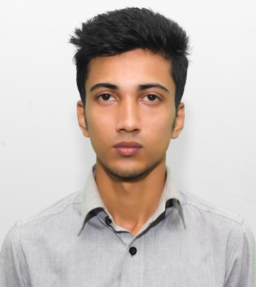
FAHIM ASHFAQUE REZA
89/A Agpara, Mirabazar, Sylhet
Cell:01751166098
Email:fahimreza56@gmail.com

Curriculam-Vitae Of
COMPUTER SKILLS | CONVERSENT WITH THE FOLLOWING COMPUTER SKILLS:
COMPUTER SKILLS |  | Operating System |  | Windows 98, 2000, XP, 7, 8
COMPUTER SKILLS |  | Word Processing |  | Microsoft Word
COMPUTER SKILLS |  | Spread Sheet Analysis |  | MS Excel
COMPUTER SKILLS |  | Presentation |  | MS Powerpoint
COMPUTER SKILLS |  | Special |  | Internet Browsing, Email, Social Networking
LANGUAGE PROFICIENCY | - Good command in English and Bengali – Both written and spoken
FAHIM ASHFAQUE REZA
Personal Information
- Name : Fahim Ashfaque Reza
- Religion: Islam
- Age: 23
- Nationality: Bangladeshi
- Father’s Name : Md. Abdul Motin
- Mother’s Name : Mrs. Shamima Begum
- Permanent Address : 28 Chaya kunjo, City R/A, Bagbari, Sylhet
- Experience: 1 year as Manager in Rafi Tailors.
- Blood Group: O+
- Others : Good Communication skills.
    - Good with computers.
    - Very punctual and good problem solving capacity.
    - Ability to work under pressure.
    - Studied CA for a period of time.
    - Good at following orders.

