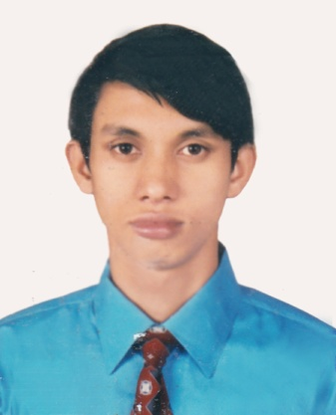
CURRICULUM VITAE
OF
Rezaul Haque
PHONE: +8801738535919
E-mail:tusherchowdhury76@gmail.com

OBJECTIVE
I would like to be a part of an organization where I can get chance to apply all my theoretical and practical skills as well as get opportunity to learn advance publications and technologies related to my profession.

ACADEMIC QUALIFICATION
4 Years Diploma in Engineering (Electronics)
Examination : Diploma in Engineering.
Institute : Habiganj Govt. Polytechnic Institute.
Department : Electronics.
Roll : 553995
Year of Passing : 2015
Result : CGPA (3.31 Out Of 4.00)
Authority : Bangladesh Technical Education Board.

S.S.C
Examination : SSC
School : Mirpur FN High School.
Group : Science.
Roll : 105018
Year of Passing : 2011
Result : GPA (4.38 Out Of 5.00)
Authority : Sylhet Board

TECHNICAL SKILLS AND KNOWLEDGE (COMPUTER)
Application programs : Microsoft Office Standard (MS Word, MS Excel, MS Access,
Photoshop- Internet Browsing etc). E-Cad, Auto-Cad,

TRAINING
Training Details : Programmable Logic Controller (PLC) & Micro Controller.
Institution : Tahmid Technologies
Farmget Concord Tower, Dhaka.1219
Phone: 01616365636,01611824643
E-Mail:tahmidgrup@gmail.com
Web:www.tahmidgroup.com

LANGUAGE SKILL
Bengali : Mother-tongue.
English : Standard.

SELF ASSESSMENT
I am hard-working and want to do my job honestly. I want to be punctual and like to face challenges and I have the ability to work under pressure.

PERSONAL INFORMATION
Name : Rezaul Haque
Father’s Name : Jamal Miah
Mother’s Name : Shamima Akther
Date of birth : 22-12-1994
Permanent add : Vill-Hafizpur, P/O- Lashkarpur,
Upz-Bahubal, Dist-Habiganj.
Contact Number : +8801738535919, 01903671365
Nationality : Bangladeshi (by birth).
Religion : Islam
Marital Status : Unmarried.
Sex : Male
Height : 5’ 7”

Experiance
Serchlite Communication Ltd.
Banglalink (6 Months Project)
Field Support Service Officer
1st April 2017 to1st November 2017
Rahim Tower, Sylhet
Nikunjo-2, Dhaka

Samsung Electronics Bangladesh
Excel Telecom Pvt. Ltd.
X Telecom Pvt. Ltd.
Showroom Executive (RSA)
1st August 2016 to 1st March 2017
Alamgir Tower, House # 11/B
Road # 55, Gulshan-2, Dhaka

DECLARATION
I, the undersigned declare that the information provided in this resume is true to the best of my belief and knowledge and correctly describes my qualification and myself.

Rezaul Haque

