Md. Ashraful Islam
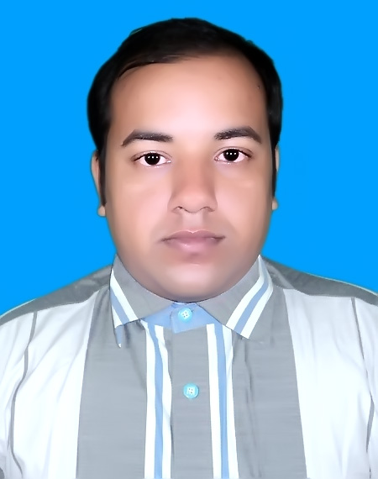
B.Sc (Engineer) In Electrical &
Electronics Engineering.
Begum Rokeya University, Rangpur.
Contact No: +8801839465029
Email: ridoymollik102030@gmail.com

CAREER OBJECTIVE
To pursue a highly challenging career in a professional work driven environment where I can utilize and apply my knowledge, skills which would enable me as a fresh graduate to grow while fulfilling organizational goals.

INTERPERSONAL SKILL
- Good Communication Skill over English and Bengali
- Ability to rapidly build relationship and set up trust.
- Confident and Determined.
- Ability to cope up with different situations.
- Capability with Innovation and Quick Learning.

BASIC ACADEMIC CREDENTIALS
Exam Title | Concentration/Major | Institute | Result | Pas.Year | Duration
Bachelor of Science BSc(Engineering) | Electrical and Electronics Engineering | Begum Rokeya University | CGPA:3.22  out of 4 | 2017 | 2012-2016
HSC | Science | B.A.F. Shaheen College, Tejgaon | CGPA:5  out of 5 | 2012 | 2010-2011
SSC | Science | Betil High School, Sirajgonj | CGPA:5  out of 5 | 2010 | 2008-2009

PROFESSIONAL EXPERIENCE
Working as a Radio Frequency Engineer in Crystal Future Venture Ltd.(CFVL)
From 1st February 2018 still now.
TECHNICAL SKILLS
- Platform: Windows XP, Windows 7, Windows 8.1, Windows 10, Linux Operating System
- Programming Language: C, Java
- Assembly language: For 8085 microprocessor, For AVR microcontrollers
- Application Oriented: VHDL, Verilog
- Programming Simulation Software: Code Blocks, TurboC, Xilinx 9.2i, Keil microvision5, AVR studio4, Eclipse, Netbeans-8.2
- Visual Simulation Software: Proteus 8.1, Matlab R2014a, AutoCAD 2010
- Office Package: Microsoft Word, Microsoft Power Point and Microsoft Excel

EXTRA –CURRICULUM ACTIVITIE.
- Involvement in social welfare activities.
- Sports (Cricket, Badminton, Carom, Chess).
- Member of debating club.

PERSONAL DETAILS
- Name :- Md. Ashraful Islam
- Father’s Name :- Md. Fazlul Haque
- Mother’s Name :- Mohabbati Begum
- Permanent Address :- Village: Goprekhy, Thana: Belkuchi, P/O: Betil, Sirajgonj
- Present Address :- Mirpur 1 ,Dhaka 1216
- Date of Birth :- 1st January 1996
- Nationality :- Bangladeshi by birth
- Religion :- Islam
- Gender :- Male
- Blood Group :- A+
REFERENCES
Reference-1
- Name: Joarder Jafor Sadique
- Designation: Assistant Professor
- Dept. of Electrical & Electronics Engineering
- Begum Rokeya University, Rangpur.
- Cell Phone: +8801711184319

Reference-2
- Md. Ferdous Rahman
- Designation: Assistant Professor
- Dept. of Electrical & Electronics Engineering
- Begum Rokeya University, Rangpur.
- Cell Phone: +8801722399402

DECLARATION
I authorized the signature below and clarify that above information in my curriculum vitae is accurate.

Signature:

