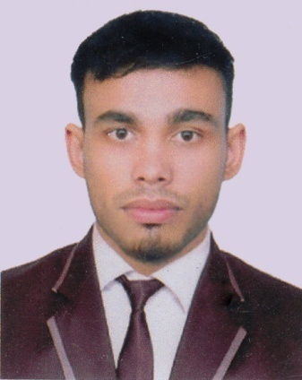
Resume of
Ridwan Ahmed
E-mail: ridwanahmed331@gmail.com
Cell: 01636215482

Address of Correspondence:
Shahjalal Super Market, Nehari Para
Akhalia,Sylhet.
Educational Status

Examination Examination Year
Bsc-in Engineering Examination
Department of computer Science & Engineering.
Running Student
Metropolitan University ,Sylhet

Diploma-in Engineering Examination
GPA-3.67 Out of 4:00 2018
Computer Technology
Bangladesh Technical Education Board ,Dhaka

SSC Examination
GPA-4.85 Out of 5:00 2014
Electrical Technology
Bangladesh Technical Education Board ,Dhaka

Major Courses Attended

English language Skills,Ielts course,Digital marketing,progarming contest,Quize contest,Computer Networking With linux CCNA & Concept Course,programming in C&C++,Advanced Graphics Design,Web Design Etc.

Experience

- Two Years experience of teaching in Two different academaaic coaching center.
Named;
- Prokousholi coaching center , polytechnical road,sylhet
(From December 2016 to present as an programming in C & Computer Networkig lecturer dealing with Diploma student)
- Giyangriho Coaching Center,Chhatak,Sunamgonj
(From December 2017 to present as an ICT lecturer dealing with HSC student)
- Codetech IT-Solution,Gazipur,Jodebpur,Dhaka.
(From February 2018 industrial training of 6th month Works)
- Ureca Coaching Center ,Madina market,Sylhet

(From December 2019 to present as an ICT lecturer dealing with HSC student)

- Experience in tuition dealing with diploma students.
Computer Skills

- MS Office,MS Excel,MS Powerpoint ,Ms Access,Internet browsing,Photoshop&able to use different software,Up work,graphics design,illustrator,programming in C&C++,CCNA and web design Etc.

Language Profeciency

- Good enough to speak and write fluently both in English and Bengali.
Interests

- Reading Books,Listening Music,Travelling,Playing Football&Cricket.

Extra Curricular Activities

- Member of Sylhet Polytechnic Institute Computer’s Club.
- Member of ‘boosters’ a blood donating Society.
- Member of Sylhet Polytechnic Institute Mozila Firefox Club.
- Member of Sylhet Polytechnic Institute Progarmming Club.
- Member of Treater club, Metropolitan university,Sylhet
- Member of Rubotics club, Metropolitan university,Sylhet

Personal Details

Name : Ridwan Ahmed
Father’s Name : Muhibur Rahman
Mother’s Name : Fatema Begum
Date of Birth : April 05,1998
Nationality : Bangladeshi
Religion : Islam
Matrial Status :Unmarried
Blood Group : B+(ve)
Present Address : Shahjalal Super Market, Nehari Para ,Akhalia,Sylhet.
Permanent Address : Poylon Pur,Rampur Bazar,Chhatak,Sunamgonj,

Acknowledgement

I hearby declare that submitted information is true and authentic. I have not concealed any fact or information.

(Ridwan Ahmed)
Date:24/06/2019

