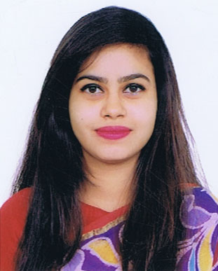

RIFA RAFIA RABBI
Contact Address: Mohammadia Housing Limited, House No: 193, Road No:5, Mohammadpur, Dhaka- 1216
Contact No.:+88-01742312810
- mail: gunjan42.bu@gmail.com

Objective:

Achieve a challenging position in a reputed organization where I can make use of my management, communicating & organizing skills, academic knowledge and experience to pursue organizational goals and objectives.

Education Background:

Exam title | Major | Institute | Result | Pass year
Masters of Law (LL.M) | Law | Southeast University | CGPA: 3.74 out of 4.00 | 2018
Bachelor of Law (LL.B) | Law | BRAC University | CGPA: 3.01 out of 4.00 | 2016
H.S.C | Science | Thakurgaon Govt. College | CGPA: 4.50out of 5.00 | 2010
S.S.C | Science | Thakurgaon Govt. Girls’ High School | CGPA:  5.00 out of 5.00 | 2008

Work Experiences:

Worked as a regular singer at Thakurgaon Radio Centre. 2003-2016.
- Private Tutor: Tutored students of Play Group up to class 10

Achievements:

Achieved Junior Scholarship in General Grad.

Achieved 3rd place in Bangabondhu Natinal Children Award Competition, 2004.
- Successfully completed Recitation and Articulation activity.
- Achieved 3rd place in Intra University Dance competition.

Extracurricular Activities:

  - Executive in BRAC University Law Club- A renowned club in BRAC University (2014 to 2015)
  - General member in BRAC University Cultural Club.(2012-2014).
  - Participated in Intra University Dance Competition, organized by BRAC University Cultural Club, 2013.
  - Organized Reunion Program of 2008 batch of Thakurgaon Govt. Girls’ and Boys’ School,2014.

Training &Seminars:
  - Attended 3 months training in BRAC University Savar Campus During Residential semester on community living punctuality, team work and ethical values.
  - Attended a workshop on Anger Management at BRAC University Savar Campus.
  - Attended a session on grooming Etiquettes at BRAC University Savar Campus.
  - Attended a seminar on Public Health at BRAC University Savar Campus.
  - Attended a session on Liberation War of Bangladesh at BRAC University Savar Campus.
  - Conducted a drama on history of Bangladesh at BRAC University Savar Campus.
  - Attended a session on climate change at BRAC University Savar Campus.

Personal Skills:

Excellent interpersonal communications and relationship-building skills.

Attentive listener

Have persuasive communication techniques and follow through diligently.

Generally proactive

Quick Learner

Able to work under pressure.

Flexible, Adoptable and sensitive to other’s opinion.

Positive, realistic, committed and practical problem solving ability.

Done the Alternative Dispute Resolution (ADR) course where I learned how to be a Mediator and Arbitrator.

Computer Proficiency:
  - Microsoft Word • Microsoft Excel
  - Microsoft Power Point

Language skills:

Language Efficiency
Language | Speaking | Understanding | Writing
Bengali | Excellent | Excellent | Excellent
English | Excellent | Excellent | Excellent

Reference(s):

- K.Shamsuddin Mahmood
Professor.
Dean, School of Law
BRAC University.
Mobile : 01819-212520
Email: kshamsuddin@bracu.ac.bd

- Md. Jahid Mustofa
Senior Lecturer & Academic Coordinator
Southeast University.
Lawyer, Supreme Court Bangladesh.
Mobile : 01919873706
Email: jahidmustofa@gmail.com

