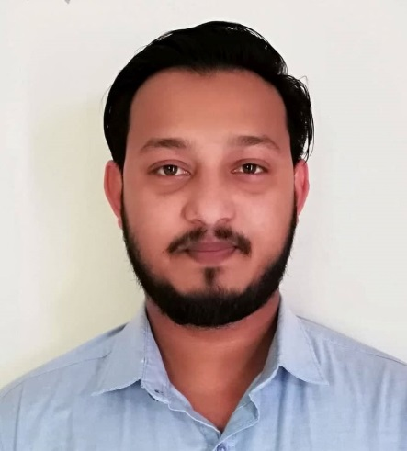

Curriculum Vita
Aminul Islam Mamun
E-mail: aminulislammamun4@gmail.com
Contact no: 01713591678/01772764589

Career Summary:
To build up a challenging and rewarding career in a well reputed organization that provides structured career advancement within the extension of competitive and dynamic environment and face challenging opportunities with sincerity, punctuality, commitments self- confidence and hard working.

Employment History: Eleven years three months.
Running Employment:
Organization Name: Decent force security service
Location: House-Tongi, Gazipura,Dhaka.
Designation: Admin Officer
Department: HR & Admin
Duration: January 1, 2019 - Continuing
Responsibilities:
1. Assist with day to operation of the HR & administrative function and duties.
2. Maintain office records file and documents update accordingly.
3. Assist to arrange conduct and process employee’s requirements and selection as per set requirements and selection policy and procedures.
4. Conduct joining of new employees and initial operation for newly hired employees.
5. Maintain automated and manual attendance and have record of employees.
6. Maintain the employee’s personal files with all related papers as updated.
7. Prepare payroll statements and salary sheets with providing relevant data(absence, bonus, leave, new joining, separation of employees etc)
8. Prepare job advertisement to contacting recruiter using newspaper and job sites.
9. Drafting HR related letter, appointment letter, NOC, re-designation letter, salary certificate, increment letter etc and exit interview analysis.
10. Assist to building and maintenance issues for general repair and updating.
11. Maintain all kind of administrative construction, transport maintenance, housekeeping, office and utility management, perches and other responsibilities.
12. Prepare reports on expanse, office budget, and other expenditure.
13. Organize special functions and social events.
14. Prepare and update all documents (VAT/TAX, company related all legal license) and maintain good reports and lesion with Govt. & Non-Govt. Official issues.
15. Assist to look after security (CCTV) personal and their activities.
16. Look after the compliance (health and safety) issues. Organization Development/ Process Improvement, Performance & Career Management, Job Analysis & Manpower Planning, Human Resources & Development also.
3rd
Organization Name: Explore Warehouse
Location :Mamensingh
Designediton:Sales Manager
Department:HR@Admin
Duration: 1st January 2017 to 31st December 2019

2nd Employment:
Organization Name: Big force Security Service Pvt LTD
Location: Chowrasta, Gazipur,Dhaka.
Designation: Admin Officer
Department: HR & Admin
Duration: 2nd January 2014 to 31 December 2016
Responsibilities:
- Assist with day to day operation of the HR & administrative functions and duties.
- Maintain office records file and documents update accordingly.
- Assist to arrange conduct and presses employee recruitment and selection as per set requirements and selection policy and procedure.
- Conduct joining of new employee and initial operation for newly hired employee.
- Maintain automated and manual attendance and have record of employees
- Maintain the employee’s personal files with all related papers as update.
- Prepare payroll statement and salary sheet with providing relevant data (absence, bonus, leave, new joining, separation of employee etc.)
- Prepare job advertisement to contacting requites using newspaper and jobsites.
- Drafting HR related letter, appointment letter, NOC, re-designation letter, salary certificate, increment letter etc. and including exit interview analysis.
- Assist to building and maintenance issues for general repair and updating.
- Maintain all kind of administrative construction, transport maintenance, housekeeping, office and utility management, perches, and other responsibilities.
- Prepare reports on expanse, office budge and other expenditure.
- Organize special function and social events.
- Prepare and update all legal documents (VAT/TAX, Company related all legal license) and maintain good reports and lesion with Govt. & non-govt. official issues.
- Assist to look after security (CCTV) personal and their activities.
- Maintain compliance (health &safety) issues.
Any other responsibilities as assigned by management.

1st Employment:
Organization name: Cumilla electronics.
Location: Mymensingh.
Designation: Seals manager
Department: HR/Admin
Duration: 1st August 2008 to 31st December 2013
Responsibilities:
Sales Duties/Responsibilities: responsible for meeting the sales targets of the organization through effective planning and budgeting. Also responsible for cash collection and cash management..
Any other responsibilities as assigned by management.

Academic qualifications:
Exam Title | Concentration/Major | Institute | Result/GPA | Pass. Year | Duration
S.S.S. | Humanity | All Hera Accademi High School | 2.75 | 2018 | 2 year

Computer Skill: Computer literacy is very good in MS word and MS excel and also experienced in software operate.
Language proficiency:
Bangla : Speaking and writing skill is very good.
English : Speaking and writing skill is very good.
Hindi : Speaking skill is very good.

Career and application information:
Looking for : Entry level job
Available for : Full time
Preferred job category : HR/Org. Development, Accounts & Finance
Preferred District : Anywhere in Bangladesh.

Personal Detail:
Fathers Name : Md foizulla.
Mothers Name : Nargis akter
Date of Birth : 20 September, 1993
Gender : Male
Marital status : Married
National ID no : 19936122007000012
Religion : Islam
Present address : House no-44,road no-33,kalshi,mirpur12,Mirpur,Dhaka 1216.
Permanent address : Fulbaria, Fulbaria, Mymensingh 2216 - Chittagong

Reference:
Name : Ashish Ranjan Dey
Organization : Dhaka Judge Court
Designation : Advocate
Mobile : 01812342284
E-mail :ashish@gmail.com
Relation : Family friend

I am undersigned hereby declare that I will be responsible for any wrong information provided here

__________________
Aminul Islam Mamun

