Name: Rima Al Mamun
Address: Mirabazar, Sylhet
Contact: +880-1776572298
Email: rimaalmamun18@gmail.com
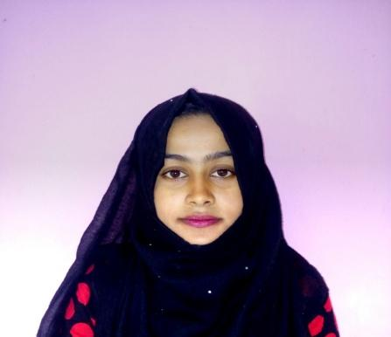
Bachelor’s Degree
B.Sc (Hon’s) in Computer Science and Engineering
Leading University, Sylhet
CGPA: 3.21
Duration: 2015-2018
Higher Secondary Graduation
Science Background
Moulvibazar Govt. College
GPA: 3.70
Duration: 2012-2014
Secondary School Graduation
Science Background
BaharMordanJoygunnesa Girls High School
GPA: 4.44
Duration: 2004-2012
Educational Qualification
Looking forward to a challenging job in the professional world where I would be able to utilize my knowledge and skills through dedication, challenge and growth-oriented activities. To work willingly in an environment where I can utilize my creativity, hardworking sincerely, honesty, timing, devotion to duty and enthusiasm to develop myself towards my aims effectively and efficiently.
Objective
Fresher
Work Experience
- Social service
- Computer gaming, Indoor and outdoor gaming
- Cooking
Extra-Curricular
- Hard Working
- Dedicated
- Maintain properly whole team
- Ability to work in independently
Strongest Point
- Expert in Microsoft Office
- Good Experience in Team Work
- Basic term of Video Editing
Inter Personal Skill

27-02-2019
Signature
Date
I do hereby declare that all the information given above is true to the best of my knowledge and belief.
Proclamation
Father Name: Abdullah –Al-Mamun.
Mother Name: Kayrunnessa
Date of Birth: May 20, 1997
Gender: Female
Marital Status: Unmarried
Nationality: Bangladeshi
Religion: Muslims
Permanent Address: Village-Goygor, Post- Voujbal, Moulvibazar-3200

Personal Data

