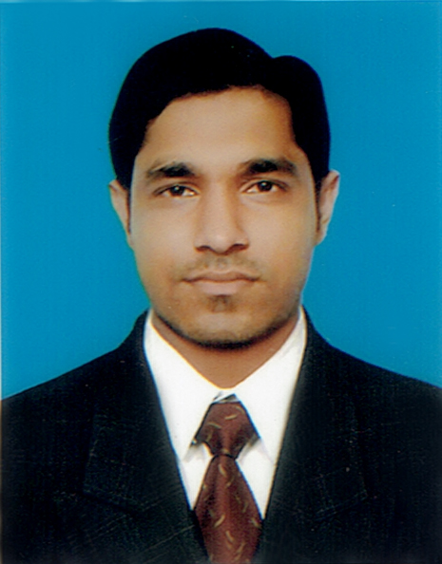
RESUME
OF
Mohammad Saifuddin Khaled
Cell # 01825102694

E-mail: Rimonsk75@gmail.com

CAREER OBJECTIVE

To obtain a responsibility and challenging position in a local or Multinational Organization that will provide me the advantages of my education, knowledge, skill and experiences and of offer me the opportunity for a successful career with future development.

EDUCATIONAL BACKGROUND

Examination : M.S.C
Institution : Govt. City College, Chittagong.
Subject : Chemistry
Result : 2.75 (out of 4.00)
Passing Year : 2016
Board : National University

Examination : B.Sc (Hon’s)
Institution : Govt. City College, Chittagong.
Subject : Chemistry
Result : 2.93 (out of 4.00)
Passing Year : 2014
Board : National University

Examination : Higher Secondary Certificate (H.S.C)
Institution : Hazera Taju Degree College
Group : Science
Result : 3.20 (Out of 5.00)
Passing Year : 2010
Board : Chittagong

Examination : Secondary School Certificate (S.S.C)
Institution : Anowara Model High School
Group : Science
Result : 3.13 (Out of 5.00)
Passing Year : 2007
Board : Chittagong.

- STRENGTHS:
- Sharp sense of social responsibility.
- Learning Mentality.
- Strong Communication Skill.

LANGUAGE PROFICIENCY:
- Fluent in Bengali and English, excellent at written and spoken in English.

INTEREST & HOBBIES
- Reading Books,
- Listening music,
- Traveling,
- Social work etc.

COMPUTER KNOWLEDGE:
- Application Software:
- MS Word,
- MS Excel
- MS Power Point
- MS Access &
- Internet Browsing.

PERSONAL INFORAMTION:
.
- Name : Mohammad Saifuddin Khaled
- Father Name : Md. Younus Chowdhury
- Mother’s Name : Nasima Akter
- Date of Birth : 14th September, 1990
- Marital Status : Single
- Home District : Chittagong
- Nationality : Bangladeshi by Birth
- Religion : Islam
- Blood Group : o+
- Permanent Address : Vill- Chatory, P.O.- Bairag,
P.S : Anowara, Dist: Chittagong

1. EXPERIENCE:
- POSITION: Senior executive
- COMPANY: Consort Flexipack Ltd. (CONSORT GROUP).
- LOCATION: BSCIC Industrial State, Kalurghat , Chittagong.
- PERIOD : 02.05.2016 to 30.04.2018

2. EXPERIENCE:
- POSITION: Chemist
- COMPANY: Olympic paint
- LOCATION: BSCIC Industrial State Nashirabad, Chattogram.
- PERIOD : 02.05.2018 to continuing

DECLARTION:

I hereby consciously ascertain that all the particulars mentioned above are true. I myself well be liable for any misinformation mentioned here with.


__________
Signature
Date: 16.09.2019

REFERENCE:
Md. Aftab Uddin Chowdhury
Manager
Admin Department, (KPP)
Youngone group

